S1. Methods
Culture and test molecules
To ensure broad applicability, standard susceptible strain (Candida albicans ATCC 90028), a resistant strain (C. albicans ATCC 10231), and a clinically isolated strain (C1) were included. C. albicans strains (ATCC 90028 and ATCC 10231) were procured from Institute of Microbial Technology, Chandigarh, India. Clinical isolate (C1) obtained from MicroPath Laboratory Kolhapur, India. Undecanal was purchased from Sigma-Aldrich Chem. LTD. Mumbai, India.
Culture media and chemicals
The strain was cultivated on a slant of Yeast-Peptone-Dextrose agar medium (YPD, Hi-Media Laboratories, Mumbai, India) and stored at 4°C. By dissolving in distilled water YPD medium was prepared and the pH was kept at 6.5. A solid medium was created with the addition of 2.5 % agar with YPD broth. Prior to each assay, a single colony from the plate was transferred into 50 mL of YPD broth subjected to a 24-hour incubation period. Cells were collected by centrifugation at 2000 rpm and washed with sterile PBS to prepare 1 × 10⁹ cells/ml. A 20% fetal bovine serum solution was prepared in sterile distilled water. Sterile distilled water buffered with MOPS was used to dissolve RPMI-1640 purchased from Hi Media Laboratories in Mumbai, India. A sterile syringe filter was used for sterilization of the medium once the pH was adjusted to 7. Concentrations of undecanal from 0.031 mg/ml to 4 mg/ml were made in RPMI-1640 and dimethyl sulphoxide was used as a solvent. The stock solution of undecanal was prepared in 2 % DMSO. Ltd. 2, 3-bis (2-methoxy-4-nitro-sulfophenyl)-2H-tetrazolium-5-carboxanilide (XTT) was obtained from SRL Pvt. Ltd. The media components, chemicals, menadione were purchased and propidium iodide (PI) was bought from Hi-Media Laboratories Ltd., Mumbai, India. Moreover, standard control was amphotericin B in current study.

Minimum Inhibitory Concentration (MIC)
The susceptibility of C. albicans (ATCC 90028 and ATCC 10231) and the C1 isolate to undecanal was assessed using the broth microdilution method, following the Standard CLSI M27-A3 guidelines. Each microtiter plate well was added with100 µl of 1×10³ cells/ml made in sterile RPMI1640 for this purpose. Also, undecanal ultimate concentrations ranged from 0.125 mg/ml to 4 mg/ml. The plate was then sealed and incubated at 35°C (48 hours). Following incubation, growth was assessed using a microplate reader to measure absorbance at 620 nm (Multiskan Sky, Thermo Fisher, USA) [1].
Minimum fungicidal concentration (MFC)
To determine the MFC the concentration of undecanal from 0.125 to 4 mg/ml, at which the MIC was achieved, was selected. C. albicans (ATCC 90028, ATCC 10231) and C1 isolate cells from the MIC plates were applied onto YPD agar and then kept for 24 h at 30 °C. The plates were checked for the development growth, and the dosage of undecanal at which inhibition of growth was observed considered as MFC [2].
Kill curve assay
Time kill assay was performed as previously described method [3]. Time required to the C. albicans (ATCC 90028, ATCC 10231) and C1 isolate cells were determined by time dependent kill curve assay method.
Adhesion assay
The C. albicans (ATCC 90028 and ATCC 10231) and C1 isolate cells at a concentration of 10⁶ cells/ml in RPMI-1640 were exposed to varying concentrations of undecanal (4 mg/ml to 0.125 mg/ml) for 90 min (37°C). Following this, the cells were washed with PBS. subsequently, XTT assay were conducted to assess the comparative adhesion [5].
Yeast to hyphal morphogenesis assay
Cells from C. albicans (ATCC 90028, ATCC 10231) and the C1 isolate cultures were used that had been incubated overnight were centrifuged at 5000 g for 2 min and then suspended in 20% FBS reaching a concentration of 2 × 10⁶ cells/ml and wells without undecanal were kept as control. Following incubation with various concentrations of undecanal in 96-well plates for 90 min at 37°C, images capturing fungal morphologies within each well were taken using an inverted microscope equipped with camera. The germ tube development percentage was calculated [6].
Biofilm formation assay
Biofilm formation was performed in tissue culture-treated 96-well plates. To facilitate cell adhesion to solid surface 100 µl cells (1 x10⁷ cells/ml) was added into every well and incubated for 90 min at 37°C. The wells were rinsed by using phosphate-buffered saline (PBS)to remove any non-adhered cells. Then RPMI-1640 medium (100 μl) was added to wells. Uncanal concentrations made in RPMI-1640 were also added to the wells, and they were incubated for 48 hours (37℃) [7].
XTT metabolic assay
After biofilm formation, the wells were rinsed twice with PBS to eliminate any non-adherent cells. After washing XTT- menadione solution (100 µl) was added to the each well. The plate was incubated at 37º C. Colour formation by water soluble formazan product was quantified using a by micro- plate reader (Multiskan sky Thermofisher) at 450 nm [8].
Scanning electron microscopy
Candida albicans (ATCC 90028 and ATCC 10231) and C1 isolate cells were kept for adhesion on silicon Foley urinary catheter pieces at 37º C for 90 min (100 rpm). A cell suspension of 1 × 10⁷ cells/ml was used for adhesion. The catheter was washed and kept in RPMI 1640 medium containing undecanal for the development of biofilm. The samples were initially fixed in 2% glutaraldehyde at 4º C for 24 h for proper preservation and structural analysis, samples were subsequently dehydrated through a series of graded alcohol solutions concentrations to remove any remaining water and prepare them for scanning electron microscopy (SEM) analysis. The samples were mounted onto stubs and sputter-coated with a layer of gold using an automated gold coater. By using SEM JEOL 6360 (JEOL, Tokyo, Japan) images were obtained [9].
Gene expression Studies
RNA extraction and cDNA synthesis
Expression of biofilm genes was measured by using RTPCR during biofilm development and during planktonic growth. C. albicans ATCC 90028 cells were inoculated and incubated for 2h with concentration of undecanal inhibiting biofilm and planktonic growth. Wells without undecanal served as controls. RNA was extracted using the RNeasy® Mini Kit (QIAGEN, USA) and reverse transcribed to cDNA by using Super Script® III First Strand Synthesis (Invitrogen, Life Technologies, USA). PCR amplification was done using the KAPA SYBR® Fast qPCR Kit Master Mix in 96-well PCR plates. The thermal cycling conditions consisted of initial denaturation at 95°C (3 minutes), followed by 32 cycles of denaturation for 30 sec at 95°C, annealing for 20 sec at 60°C. The primer extension at 72°C for 30 seconds. Real-time PCR was conducted using the Bio-Rad CFX 96 Real-Time System [10].
Primers
The primers were provided by Bangalore, India Pvt. Ltd.'s Eurofins Genomics. Actin was used as an internal control gene, acting as a housekeeping gene (Table. 1).
Cell cycle analysis
Log- phase cells of C. albicans (ATCC 90028 and ATCC 10231) and C1 isolate were harvested from 24 h grown culture. Cells were washed with PBS and 2 × 10⁷ cells were added in 10 ml RPMI1640 containing 1 mg/ml of undecanal. RPMI 1640 without undecanal were kept as control. The flask was incubated at 30ºC (4 h). Cells were centrifuged at 6000 rpm (3 min) to get cell pellet (REMI, India). The supernatant was carefully removed, and the cell pellet was resuspended in an appropriate buffer for further analysis or processing. The cells were washed with chilled PBS and fixed by using absolute alcohol. The following day, the alcohol-fixed cells were washed with PBS and 10 µg RNase A was added. After the treatment of RNase A propidium iodide (50 µg/ml) solution was added and incubated for 30 min (4 ℃). The cells were analysed (FACS Diva Version 6.1.3) [11].
Ergosterol assay
A colony from 24 h old Sabourad dextrose agar (SDA, Hi media, Mumbai, India) plate was inoculated in 50 ml of Sabourad broth (Hi media, Mumbai, India) flasks containing series of concentrations of undecanal. All the flasks were incubated at 30º C for 16 h. The cells were harvested by centrifugation. The weight of the pellet was taken. The 3 ml of 25% alco. KOH solution was added and vortexed. The cell suspensions were transferred into sterile glass screw-cap tube and incubated in a water bathe at 85º C. Tubes were permitted to cool. The sterols were extracted by 3 ml of n- heptane and 1 ml of distilled water with vortex mixing. The upper layer was carefully transferred into sterile glass screw-cap tubes and stored at -20 ℃. Then scanned between 240 nm to 300 nm spectrophotometrically (Multiskan Sky Thermofisher) [11].
Effect of undecanal on cell membrane integrity
The red fluorescent dye with membrane impermeability PI, served as a common method for assessing plasma membrane damage. In this study, to assess the impact of undecanal on membrane integrity of C. albicans (ATCC 90028 and ATCC 10231) and C1 isolate. Cells were treated with the different concentrations of undecanal. After treatment, cells were gathered via centrifugation and underwent washing with PBS. These cells were suspended in PBS (50 μl) and exposed to PI in darkness. Subsequently, the cells were observed under a fluorescence microscope at 40 × (Nikon, T1-SAM JAPAN) [12].
Assessing Reactive Oxygen Species Generation in C. albicans
The measurement of ROS was done according to previously described method with slight modifications [13]. C. albicans (ATCC 90028 and ATCC 10231) and C1 isolate underwent treatment with undecanal alongside 2’,7’-dichlorofluorescin diacetate to assess the levels of endogenous ROS. Logarithmic growth phase cells were exposed to undecanal at concentrations of MIC in YPD for durations of 4 h at 30°C. Following this treatment, the cells underwent three washes with PBS (pH 7.4) and were then exposed to DCFH-DA at a final concentration of 10 µM in PBS. After an incubation period of 30 min at 30°C, the samples were quantitatively examined using a spectrofluorometer at 486 nm excitation and 525 nm emission wavelengths.
Effect of undecanal on amphotericin B sensitivity in Candida albicans ATCC 90028
The effect of undecanal on the amphotericin b sensitivity of C. albicans ATCC 90028 was evaluated using the checkerboard method in combination with a broth microdilution assay. Undecanal and amphotericin b were tested in combinations, with amphotericin b concentrations ranging from 0.039 to 0.00076 µg/ml and the undecanal from 2 to 0.062 mg/ml. Each microplate was inoculated with C. albicans at density of 10³ CFU/mL, incubated at 35 °C for 48 h, and assessed visually following established in vitro susceptibility testing guidelines. Fractional Inhibitory Concentrations (FICs) were calculated for undecanal, both individually and in combination with amphotericin b. The FIC of compound was determined by dividing its concentration in a combination that inhibits growth by the concentration required to achieve the same effect when used alone. The FIC index (ΣFIC) was used to characterize the interaction between the compounds. An FIC index value close to 1 indicates an additive interaction, while values ≤ 0.5 indicate synergy and values > 4 suggest antagonism. Generally, the lower the FIC index, the greater the synergistic effect, and higher values imply stronger antagonism [14].
Haemolytic Activity
The hemolytic activity of undecanal was evaluated using human red blood cells. Blood was collected from a blood bank in EDTA-containing tubes and centrifuged at 2,000 rpm. The RBC pellet was resuspended in PBS, and this suspension was diluted in PBS. 100 µL of the RBC suspension were added to 100 µL of different concentrations of undecanal in same buffer in Eppendorf tubes. As a positive control, 0.1% Triton X-100 used to achieve complete hemolysis. The mixtures were incubated at 37°C (1 h), followed by centrifugation at 2,000 rpm (10 min). 150 µL of supernatant was transferred to a microtiter plate. The absorbance was measured at 450 nm. The hemolysis percentage was determined:
% of hemolysis = [(A450 of undecanal-treated sample – A450 of saline-treated sample) / (A450 of 1% Triton-treated sample – A450 of saline-treated sample)] × 100 [15].
Cytotoxicity assay
The cytotoxic effects of undecanal was evaluated in L929 cells according to Ozdemir et al with slight modifications. L929 cells were added into clear 96-well plates at density of 1.8× 10 ⁵ cells/well and incubated at 37℃ overnight. Different doses undecanal from 0.062 mg/ml to 0.50 mg/ml were prepared. A positive control having untreated cells. To prepare the cells, new complete media was added in place of the growth medium (DMEM + 10% FBS + 1% antibiotics). FBS and antibiotics must be added to DMEM, a basal medium, in order to make it complete medium. The different concentrations of undecanal were added to the cells and incubated at 37 ℃ (36 h). Thereafter, the growth medium was replaced with 0.1 ml of MTT solution (5 mg/ml in PBS), and the cells were incubated at 37°C for 4 hours. After adding 0.1 mL of DMSO, the absorbances were measured at 570 nm using a microplate reader.[16].

Statistical analysis

The sample size for all experiments was determined using the resource equation method, which is particularly suited for biological studies where precise variance is difficult to estimate. This method ensures an appropriate balance between achieving sufficient statistical power and adhering to ethical considerations by minimizing excessive resource usage. Triplicate experiments were conducted for each condition to ensure reproducibility and reliability. The reported values correspond to the averages and variability measures calculated from three independent observations. Statistical analyses were performed using Ms Excel. Data were expressed as mean standard deviation. The student's t-test was used for statistical analysis to compare the values between the treatment and control groups, with a p-value < 0.05 considered statistically significant [2].

S2. Results
Antifungal activity of undecanal against C. albicans
Planktonic growth of C. albicans was inhibited by amphotericin B at 0.39 µg/ml and that of the C1 isolate at 0.78 µg/ml. The MFCs were 0.7 µg/ml for C. albicans and 1.5 µg/ml for the C1 isolate, respectively. (Figure S1). Undecanal treatment significantly reduced planktonic growth showing an average 50% decrease or more than controls (p < 0.05).
Adhesion of C. albicans was inhibited by undecanal
Amphotericin B inhibited adhesion of C. albicans ATCC 90028 at concentration of 13 µg/ml and the C1 isolate at 25 µg/ml (Figure S1). Treatment with undecanal resulted in reduction of C. albicans adhesion showing a 50% or greater decrease in adhesion than controls (p < 0.05).
Undecanal inhibited filament formation in C. albicans
The MIC of amphotericin B for preventing yeast-to-hyphal morphogenesis was 1.5 µg/ml for the C1 isolate and 0.7 µg/ml for ATCC 90028. (Figure S1, S2). Treatment with undecanal resulted in reduction of hyphal formation showing an average decrease of 50% or more compared to controls (p < 0.05).
Effect of undecanal on C. albicans biofilm formation
Amphotericin B inhibited biofilm formation at 0.39 µg/ml for C. albicans ATCC 90028 and 0.78 µg/ml for the C1 isolate, whereas undecanal had no effect (Table 4). Amphotericin B was effective against mature biofilms, inhibiting biofilm at 0.7 µg/ml for ATCC 90028 and 1.5 µg/ml for the C1 isolate (Figures S1, S2).
The study suggests that treatment duration could influence the effectiveness of undecanal, with the 24-hour treatment period used in this study showing notable effects on biofilm formation. Further investigations with varying treatment durations would provide deeper insights into temporal effects of undecanal on biofilm formation and maturation. At higher concentrations like 2 mg/ml and 4 mg/ml, undecanal predominantly inhibited planktonic growth even at lower concentrations. Treatment with undecanal led to reduced biofilm formation, with an average decrease of 50% or more in biofilm adherence compared to controls (p < 0.05).
Undecanal does not cause haemolysis of human RBCs in-vitro at concentrations inhibiting virulence factors
Haemolysis assay, showed that undecanal caused haemolysis at higher concentrations like 2 mg/ml and 4 mg/ml. It did not exhibit haemolytic activity up to 0.125 mg/ml, which effectively inhibited virulence factors. Nonetheless, additional studies are needed to fully assess its safety across a range of doses and biological systems before determining its broader suitability (Figure S3).
Cytotoxicity of undecanal in L929 cells
Cytotoxicity of the compound was tested on L929 cells at concentrations of 0.062, 0.125, 0.25, and 0.5 µg/mL. At 0.062 µg/mL, cell viability remained nearly 100%. At 0.125 µg/mL, viability slightly decreased to 90%. A more significant reduction in viability was observed at 0.25 µg/mL (approximately 70%) and 0.5 µg/mL (approximately 50%). These findings suggest that the compound exhibits dose-dependent cytotoxicity in L929 cells (Figure S4).
Synergistic activity of undecanal and amphotericin b
The interaction between amphotericin B and undecanal was assessed at various concentrations. At 0.125 mg/ml amphotericin B and 0.0625 mg/ml undecanal, the combined effect reached 140, much higher than the sum of individual effects (46 for undecanal and 20 for amphotericin B), indicating strong synergy. Similarly, a combination of 0.5 mg/ml amphotericin B and 0.5 mg/ml undecanal (combined effect of 77) and 0.25 mg/ml amphotericin B and 0.125 mg/ml undecanal (combined effect of 92) showed synergistic effects as well, exceeding the expected sum of individual effects (Table S1).

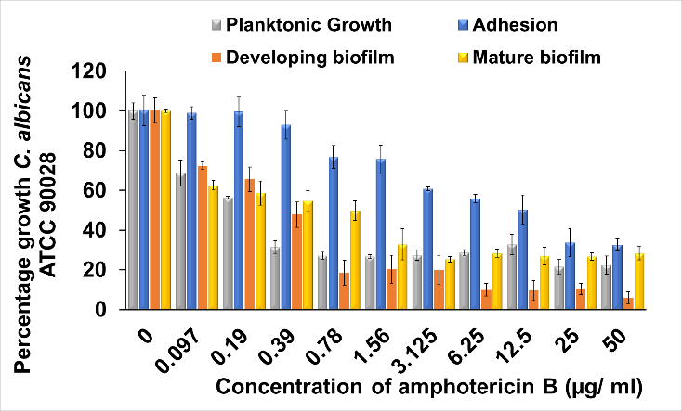
Figure S1: Effect of amphotericin B on planktonic growth, adhesion, developing biofilm and mature biofilm of C. albicans ATCC 90028.

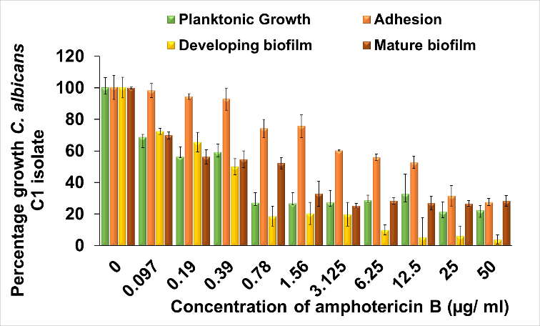
Figure S2: Effect of amphotericin B on planktonic growth, adhesion, developing biofilm and mature biofilm of C. albicans C1 isolate.

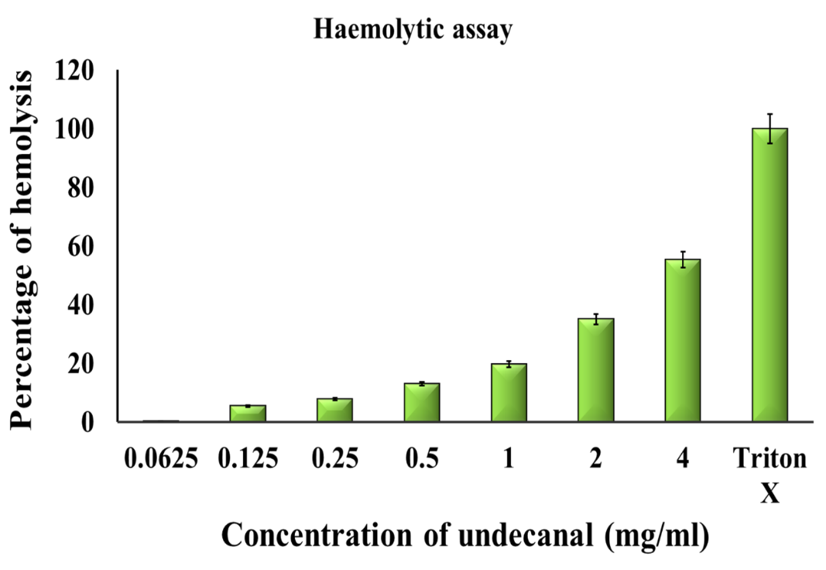
Figure S3: Haemolytic activity helps to analyse the effect of undecanal on human Red Blood Cells (RBC).

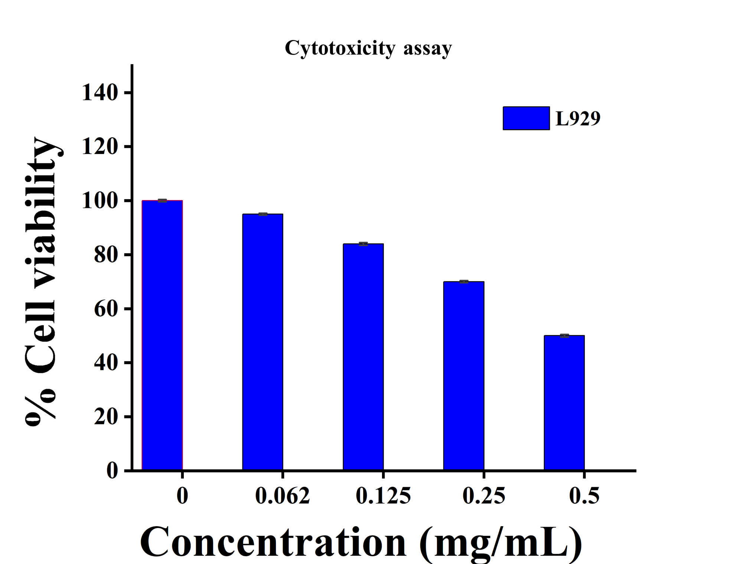
Figure S4: Percentage of cell viability (optical density) of L929 cell line after treatment with undecanal.

Table S1: Result of undecanal and amphotericin b combination as per checkerboard assay.

 | MIC alone |  | MIC combination |  | FICI | Remark
 | Undecanal (mg/ml) | Amphotericin b (µg/ml) | undecanal (mg/ml) | Amphotericin b (µg/ml)
C. albicans ATCC 90028 | 0.125 | 0.39 | 0.062 | 0.048 | 0.52 | synergistic

References
1. Gonçalves S, Silva PM, Felício MR, de Medeiros LN, Kurtenbach E, Santos NC. Psd1 effects on Candida albicans planktonic cells and biofilms. Front Cell Infect Microbiol. 2017;7(JUN):1–13.
2. Jayant S. Raut. Indole, a bacterial signaling molecule, exhibits inhibitory activity against growth, dimorphism and biofilm formation in Candida albicans. African J Microbiol Res. 2012 Aug 9;6(30):6005–12.
3. Zore GB, Thakre AD, Jadhav S, Karuppayil SM. Terpenoids inhibit Candida albicans growth by affecting membrane integrity and arrest of cell cycle. Phytomedicine. 2011;18(13):1181–90.
4. Camacho DP, Gasparetto A, Svidzinski TIE. The effect of chlorhexidine and gentian violet on the adherence of Candida spp. to urinary catheters. Mycopathologia. 2007;163(5):261–6.
5. Sun L, Liao K, Wang D. Effects of magnolol and honokiol on adhesion, yeast-hyphal transition, and formation of biofilm by Candida albicans. PLoS One. 2015;10(2).
6. Bachmann SP, Ramage G, VandeWalle K, Patterson TF, Wickes BL, López-Ribot JL. Antifungal Combinations against Candida albicans Biofilms In Vitro. Antimicrob Agents Chemother. 2003;47(11):3657–9.
7. Ramage G, Vande Walle K, Wickes BL, López-Ribot JL. Standardized method for in vitro antifungal susceptibility testing of Candida albicans biofilms. Antimicrob Agents Chemother. 2001;45(9):2475–9.
8. Lee JH, Cho MH, Lee J. 3-Indolylacetonitrile Decreases Escherichia coli O157:H7 Biofilm Formation and Pseudomonas aeruginosa Virulence. Environ Microbiol. 2011;13(1):62–73.
9. Chang W, Li Y, Zhang L, Cheng A, Lou H. Retigeric acid B attenuates the virulence of Candida albicans via inhibiting adenylyl cyclase activity targeted by enhanced farnesol production. Bassilana M, editor. PLoS One. 2012 Jul 23 2023 26];7(7):e41624–33.
10. Cerqueira F, Maia M, Gabriel C, Medeiros R, Cravo S, Ribeiro AI, et al. Mechanism of antifungal activity by 5-aminoimidazole-4-carbohydrazonamide derivatives against Candida albicans and Candida krusei. Antibiotics. 2021;10(2):1–13.
11. Ganeshkumar A, Suvaithenamudhan S, Rajaram R. In Vitro and In Silico Analysis of Ascorbic Acid Towards Lanosterol 14-α-Demethylase Enzyme of Fluconazole-Resistant Candida albicans. Curr Microbiol. 2021;78(1):292–302.
12. Ding Y, Li Z, Li Y, Lu C, Wang H, Shen Y, et al. HSAF-induced antifungal effects in Candida albicans through ROS-mediated apoptosis. RSC Adv. 2016;6(37):30895–904.
13. Zore GB, Thakre AD, Rathod V, Karuppayil SM. Evaluation of anti-Candida potential of geranium oil constituents against clinical isolates of Candida albicans differentially sensitive to fluconazole: inhibition of growth, dimorphism and sensitization. Mycoses. 2011 Jul;54(4):e99–109.
14. Ahmad A, Khan A, Manzoor N, Khan LA. Evolution of ergosterol biosynthesis inhibitors as fungicidal against Candida. Microb Pathog. 2010;48(1):35–41.
15. Ozdemir KG, Yilmaz H, Yilmaz S. In vitro evaluation of cytotoxicity of soft lining materials on L929 cells by MTT assay. J Biomed Mater Res - Part B Appl Biomater. 2009;90 B(1):82–6.

