**Supplementary Document 1**

**Table S1. Protein structure retrieval along with their accession IDs.**

|  |  |  |  |  |
| --- | --- | --- | --- | --- |
| **Genes** | | **Protein** | **UniProt IDs** | **Accession ID** |
| cka1 | | CMGC/CK2 protein kinase | J9VNH4 | 6K3L |
| ckb1 | | Casein kinase II subunit beta | J9VQR1 | AF-J9VQR1-F1 |
| ckb2 | | Casein kinase II subunit beta | J9VM18 | AF-J9VM18-F1 |
| **Conditions** | **Genes** | **Protein** | **UniProt IDs** | **Accession ID** |
| cka1Δ | Q5KFT2_CRYNJ | Pyruvate carboxylase | Q5KFT2 | AF-Q5KFT2-F1 |
| ARO1_CRYNJ | Pentafunctional  AROM polypeptide | P0CM22 | AF-P0CM22-F1 |
| Q5KL19_CRYNJ | Glycine cleavage system P protein | Q5KL19 | AF-Q5KL19-F1 |
| Triple | Q5KC42_CRYNJ | Glyceraldehyde-3-phosphate dehydrogenase | Q5KC42 | AF-Q5KC42-F1 |
| Q5KNI6_CRYNJ | 60s ribosomal protein l7, putative | Q5KNI6 | AF-Q5KNI6-F1 |
| wild-type strain | Q5KCS1_CRYNJ | 60S ribosomal protein L8 | Q5KCS1 | AF-Q5KCS1-F1 |
| Q5KNH2_CRYNJ | Ribosomal protein S11, putative | Q5KNH2 | AF-Q5KNH2-F1 |
| Q5KA46_CRYNJ | Ribosomal protein S18, putative | Q5KA46 | AF-Q5KA46-F1 |
| Q5KEV1_CRYNJ | Ribosomal protein S2, putative | Q5KEV1 | AF-Q5KEV1-F1 |
| Q5KFT0_CRYNJ | Structural constituent of ribosome, putative | Q5KFT0 | AF-Q5KFT0-F1 |
| Q5KAB9_CRYNJ | Ribosomal protein, putative | Q5KAB9 | AF-Q5KAB9-F1 |
| Q5KN73_CRYNJ | Ribosomal protein L35, putative | Q5KN73 | AF-Q5KN73-F1 |
| Q5KLJ6_CRYNJ | Structural constituent of ribosome, putative | Q5KLJ6 | AF-Q5KLJ6-F1 |
| Q5KHQ2_CRYNJ | Large ribosomal subunit protein eL39 | Q5KHQ2 | AF-Q5KHQ2-F1 |

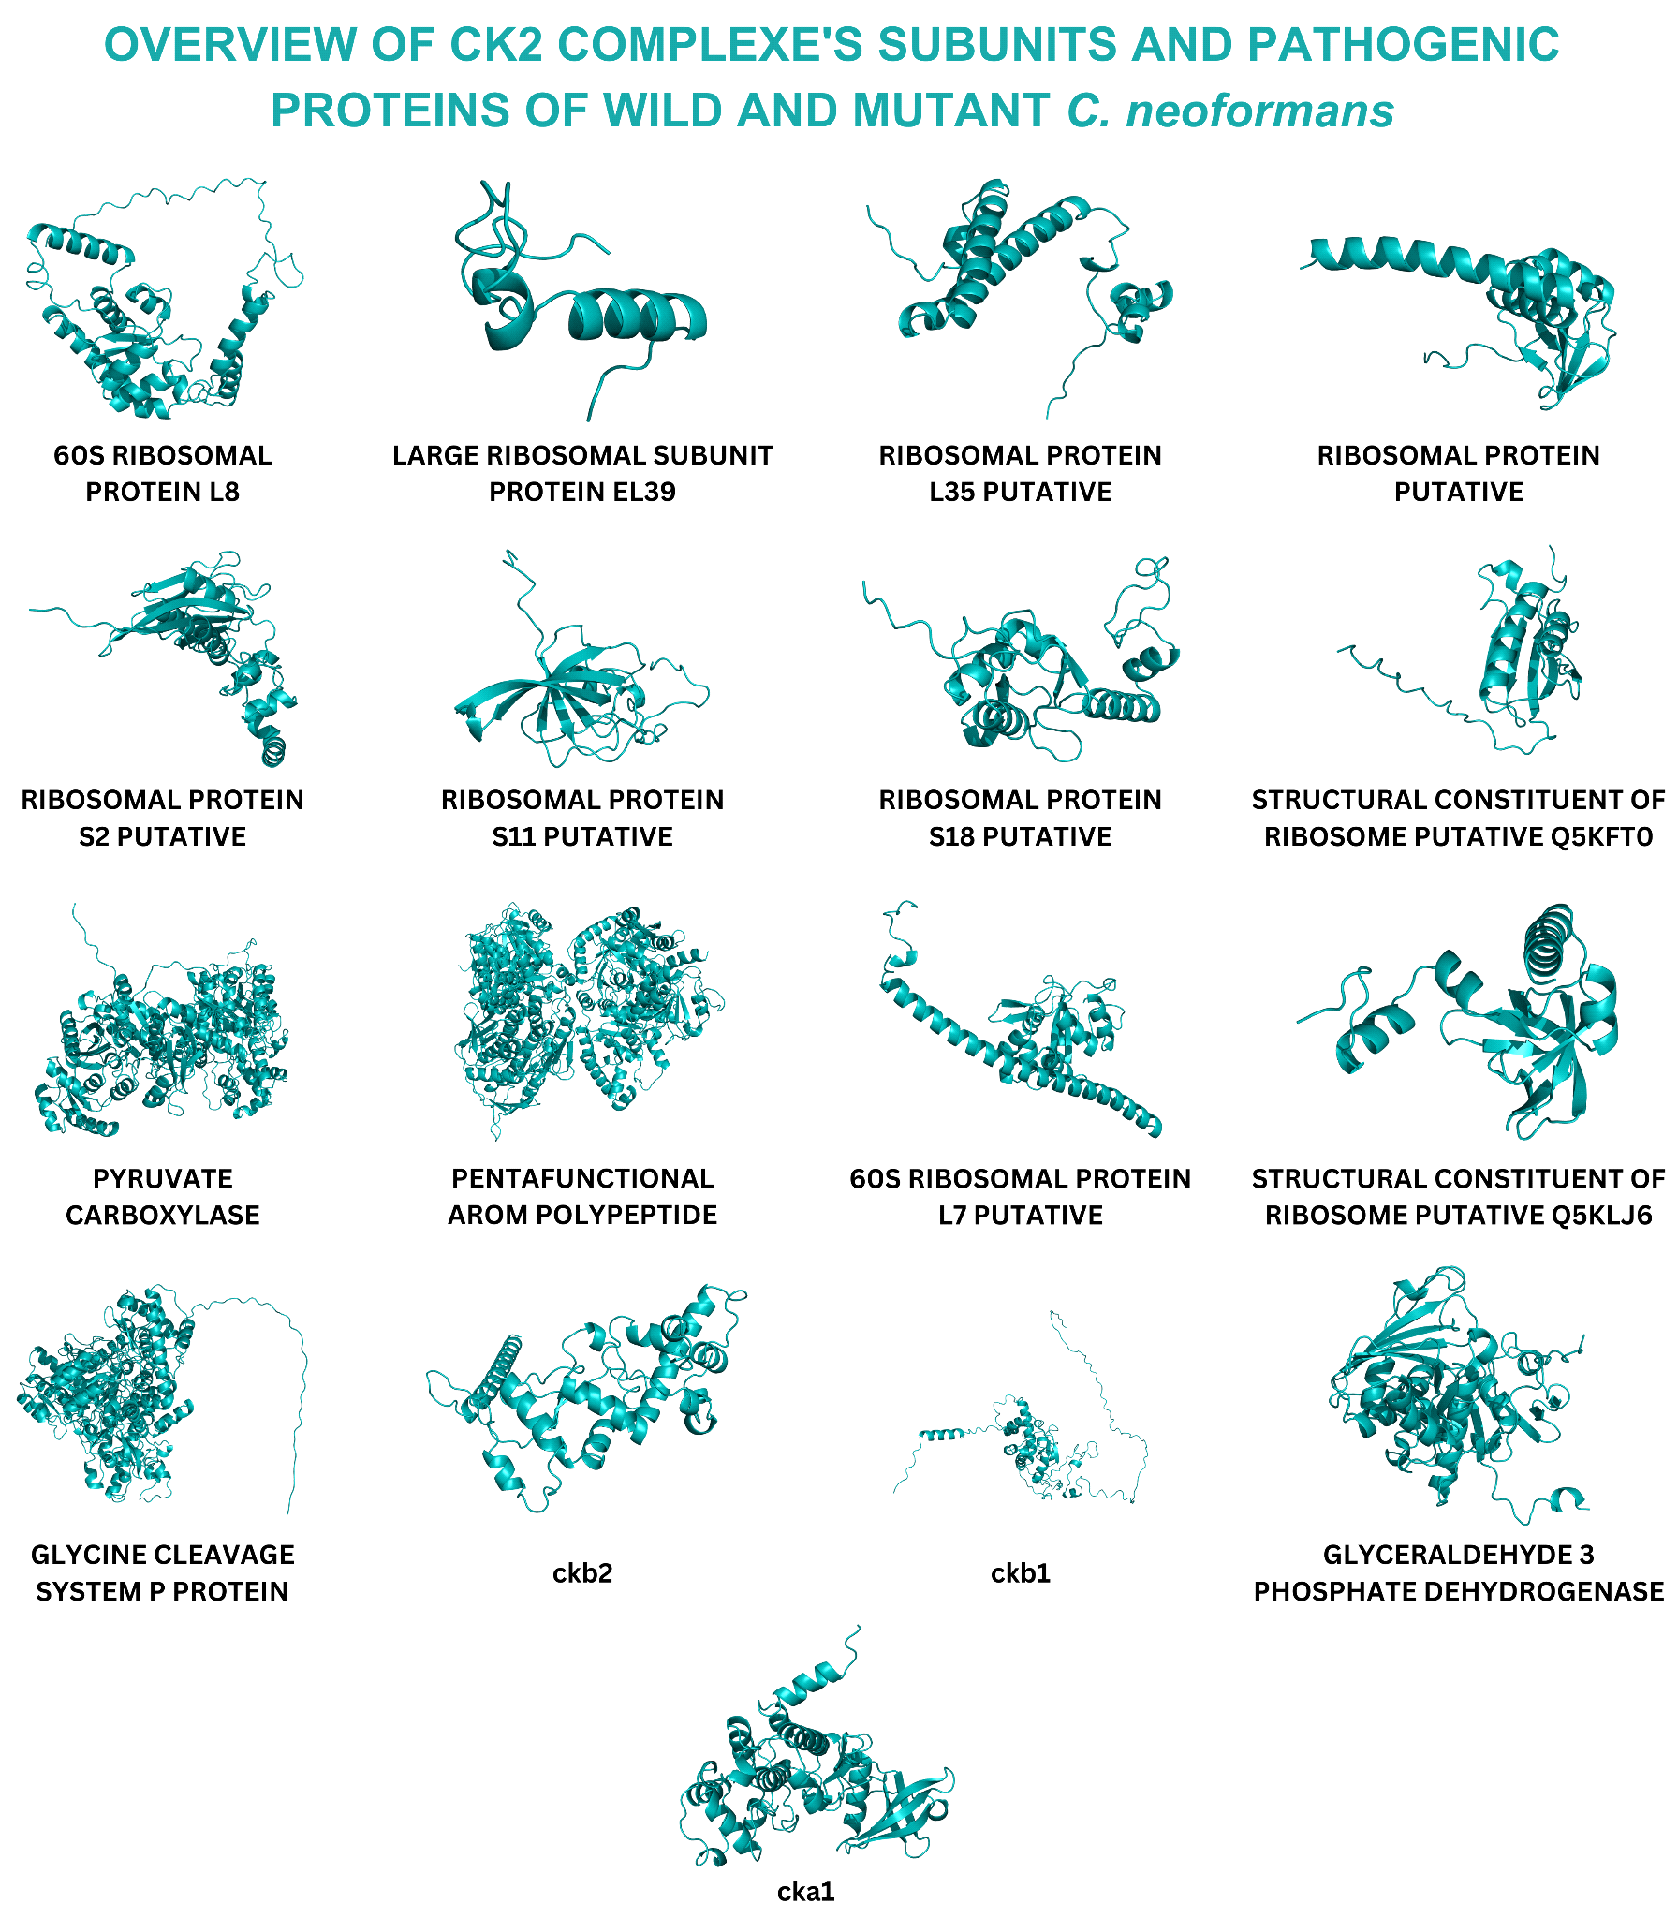

**Figure S1.** Illustration of the overview structures of candidate therapeutic target proteins of the cka vs wild-type strain, triple vs wild-type strain, and wild-type strain vs all mutant conditions.

**Table S2.** Domain analysis of selected target proteins.

|  |  |  |  |  |
| --- | --- | --- | --- | --- |
| **Genes** | | **Proteins** | **UniProt ID** | **Domain** |
| cka1 | | CMGC/CK2 protein kinase | J9VNH4 | * Protein kinase domain (38 - 323) |
| ckb1 | | Casein kinase II subunit beta | J9VQR1 | * No Domain |
| ckb2 | | Casein kinase II subunit beta | J9VM18 | * No Domain |
| **Conditions** | **Genes** | **Proteins** | **UniProt ID** | **Domain** |
| cka1Δ | Q5KFT2_CRYNJ | Pyruvate carboxylase | Q5KFT2 | * Pyruvate carboxyltransferase (589-862) * Carboxylase, conserved domain (885 -1085) * Carbamoyl-phosphate synthetase large subunit-like, ATP-binding domain (168 -376) * Biotin carboxylase-like, N-terminal domain (54 -163) * Biotin carboxylase, C-terminal (392-499) * ATP-grasp fold (173 - 370) * Biotin carboxylation domain (53-503) |
| ARO1_CRYNJ | Pentafunctional  AROM polypeptide | P0CM22 | * Enolpyruvate transferase domain (417-857) * 3-dehydroquinate synthase AroB (19-393) * 3-dehydroquinate synthase domain (79 -365) * Quinate/shikimate 5-dehydrogenase/glutamyl-tRNA reductase (1449-1521) * Shikimate dehydrogenase, AroM-type (1328 - 1605) * Shikimate dehydrogenase substrate binding, N-terminal (1336 - 1417) |
| Q5KL19_CRYNJ | Glycine cleavage system P protein | Q5KL19 | * Glycine cleavage system P-protein, N-terminal domain (76-520) * Glycine dehydrogenase, C-terminal domain (869 - 989) |
| Triple | Q5KC42_CRYNJ | Glyceraldehyde-3-phosphate dehydrogenase | Q5KC42 | * Glyceraldehyde 3-phosphate dehydrogenase, NAD(P) binding domain (17 - 167) * Glyceraldehyde 3-phosphate dehydrogenase, catalytic domain (172 - 335) |
| Q5KNI6_CRYNJ | 60s ribosomal protein l7, putative | Q5KNI6 | * Large ribosomal subunit protein uL30, N-terminal, eukaryotes (15 - 86) * Large ribosomal subunit protein uL30-like, ferredoxin-like fold domain (91 - 141) * Large ribosomal subunit protein uL30, eukaryotic/archaeal (90 - 250) |
| wild-type strain | Q5KCS1_CRYNJ | 60S ribosomal protein L8 | Q5KCS1 | * Ribosomal protein eL8/eL30/eS12/Gadd45 (134 - 209) |
| Q5KNH2_CRYNJ | Ribosomal protein S11, putative | Q5KNH2 | * Small ribosomal subunit protein uS17, N-terminal (4 - 70) |
| Q5KA46_CRYNJ | Ribosomal protein S18, putative | Q5KA46 | * No Domain |
| Q5KEV1_CRYNJ | Ribosomal protein S2, putative | Q5KEV1 | * Small ribosomal subunit protein uS5, N-terminal (75 - 139) * Small ribosomal subunit protein uS5, C-terminal (159 - 229) |
| Q5KFT0_CRYNJ | Structural constituent of ribosome, putative | Q5KFT0 | * No Domain |
| Q5KAB9_CRYNJ | Ribosomal protein, putative | Q5KAB9 | * Large ribosomal subunit protein eL14 domain (50 - 124) * KOW (9 - 42) * Large ribosomal subunit protein eL14, KOW motif (10 - 85) |
| Q5KN73_CRYNJ | Ribosomal protein L35, putative | Q5KN73 | * No Domain |
| Q5KLJ6_CRYNJ | Structural constituent of ribosome, putative | Q5KLJ6 | * KOW (48 - 87) * Large ribosomal subunit protein uL24, KOW domain (52 - 105) |
| Q5KHQ2_CRYNJ | Large ribosomal subunit protein eL39 | Q5KHQ2 | * No Domain |

**Table S3.** The candidate therapeutic proteins in cka1Δ, triple, and wild-type strain conditions showing top-best binding affinities with their respective compounds

|  |  |  |  |  |  |
| --- | --- | --- | --- | --- | --- |
| **Gene** | **Protein** | **Uniprot ID** | **Top-scoring compound (ChEMBL ID)** | **Compound Name** | **Affinity** |
| ARO1_CRYNJ | Pentafunctional  AROM polypeptide | P0CM22 | CHEMBL267345 | AMPHOTERICIN B | -13.89 |
| cka1 | CMGC/CK2 protein kinase | J9VNH4 | -13.36 |
| Q5KNI6_CRYNJ | 60s ribosomal protein l7, putative | Q5KNI6 | -12.81 |
| Q5KL19_CRYNJ | Glycine cleavage system P protein | Q5KL19 | CHEMBL1117 | IDARUBICIN | -12.76 |
| Q5KC42_CRYNJ | Glyceraldehyde-3-phosphate dehydrogenase | Q5KC42 | CHEMBL267345 | AMPHOTERICIN B | -12.65 |
| Q5KFT2_CRYNJ | Pyruvate carboxylase | Q5KFT2 | -12.26 |
| ckb1 | Casein kinase II subunit beta | J9VQR1 | -11.91 |
| Q5KCS1_CRYNJ | 60S ribosomal protein L8 | Q5KCS1 | -11.49 |
| Q5KEV1_CRYNJ | Ribosomal protein S2, putative | Q5KEV1 | -11.4 |
| ckb2 | Casein kinase II subunit beta | J9VM18 | -11.15 |
| Q5KA46_CRYNJ | Ribosomal protein S18, putative | Q5KA46 | CHEMBL1200647 | CANDICIDIN | -10.93 |
| Q5KNH2_CRYNJ | Ribosomal protein S11, putative | Q5KNH2 | CHEMBL1117 | IDARUBICIN | -10.89 |
| Q5KN73_CRYNJ | Ribosomal protein L35, putative | Q5KN73 | CHEMBL267345 | AMPHOTERICIN B | -10.11 |
| Q5KAB9_CRYNJ | Ribosomal protein, putative | Q5KAB9 | CHEMBL1200647 | CANDICIDIN | -10.01 |
| Q5KFT0_CRYNJ | Structural constituent of ribosome, putative | Q5KFT0 | CHEMBL267345 | AMPHOTERICIN B | -9.87 |
| Q5KLJ6_CRYNJ | Structural constituent of ribosome, putative | Q5KLJ6 | -9.75 |
| Q5KHQ2_CRYNJ | Large ribosomal subunit protein eL39 | Q5KHQ2 | -9.55 |

**Table S4.** Putative binding residues of top-scoring candidate therapeutic target proteins with respective domains.

|  |  |  |  |  |
| --- | --- | --- | --- | --- |
| **Gene** | **Compound name** | **Residues** | **Amino acids (AA)** | **Domain of interaction** |
| cka1 | AMPHOTERICIN B | 49A  49A  49A  117A  190A  190A  193A  194A | TYR  TYR  TYR  ASN  ARG  ARG  SER  ARG | Within the domain   * Protein kinase domain (32-338) |
| ckb1 | AMPHOTERICIN B | 126A  141A  232A  232A  249A  249A | TYR  ALA  ALA  ALA  ARG  ARG | No Domain |
| ckb2 | AMPHOTERICIN B | 27A  114A  115A  117A  121A  122A  122A  153A  190A | GLU  ARG  CYS  ARG  TYR  SER  SER  LYS  SER | No Domain |
| Q5KFT2_CRYNJ | AMPHOTERICIN B | 136A  140A  140A  345A  345A  394A  394A  441A  441A | GLY  GLU  GLU  ARG  ARG  ARG  ARG  SER  SER | * Carbamoyl-phosphate synthetase large subunit-like, ATP-binding domain (168 -376) * Biotin carboxylase-like, N-terminal domain (54 -163) * Biotin carboxylase, C-terminal (392-499) |
| ARO1_CRYNJ | AMPHOTERICIN B | 1079A  1082A  1087A  1114A  1153A  1153A | ASN  ARG  ASN  ASP  THR  THR | Not in domain |
| Q5KL19_CRYNJ | IDARUBICIN | 181A  391A  395A  395A  921A  922A  932A  934A | SER  ARG  GLN  GLN  SER  LYS  PRO  ALA | * Glycine cleavage system P-protein, N-terminal domain (76-520) * Glycine dehydrogenase, C-terminal domain (869 - 989) |
| Q5KC42_CRYNJ | AMPHOTERICIN B | 113A  116A  166A  168A  198A  226A  228A  249A  249A  337A | SER  LYS  SER  THR  SER  THR  ALA  ARG  ARG  ASN | * Glyceraldehyde 3-phosphate dehydrogenase, NAD(P) binding domain (17 - 167) * Glyceraldehyde 3-phosphate dehydrogenase, catalytic domain (172 - 335) |
| Q5KNI6_CRYNJ | AMPHOTERICIN B | 62A  66A  66A  89A  90A  90A  145A  146A  148A  196A  196A | TYR  GLU  GLU  LYS  VAL  VAL  GLU  VAL  LEU  ALA  ALA | * Large ribosomal subunit protein uL30, N-terminal, eukaryotes (15 - 86) * Large ribosomal subunit protein uL30-like, ferredoxin-like fold domain (91 - 141) * Large ribosomal subunit protein uL30, eukaryotic/archaeal (90 - 250) |
| Q5KCS1_CRYNJ | AMPHOTERICIN B | 62A  66A  75A  79A  157A  158A  160A  185A  187A | LYS  ASN  ILE  SER  ASP  ASP  ASP  LYS  ARG | * Ribosomal protein eL8/eL30/eS12/Gadd45 (134 - 209) |
| Q5KNH2_CRYNJ | IDARUBICIN | 2A  16A  31A  31A  32A | ALA  GLN  LYS  LYS  ARG | * Small ribosomal subunit protein uS17, N-terminal (4 - 70) |
| Q5KA46_CRYNJ | CANDICIDIN | 35A  41A  41A  89A  91A  155A | GLU  ARG  ARG  ARG  ARG  LYS | No Domain |
| Q5KEV1_CRYNJ | AMPHOTERICIN B | 56A  57A  59A  59A  60A  135A | TYR  LEU  SER  SER  LEU  ILE | Within the domain   * Small ribosomal subunit protein uS5, N-terminal (75 - 139) |
| Q5KFT0_CRYNJ | AMPHOTERICIN B | 23A  24A  24A  86A  90A  90A | GLY  GLU  GLU  GLU  THR  THR | No Domain |
| Q5KAB9_CRYNJ | CANDICIDIN | 36A  63A  93A  98A  102A | HIS  TYR  SER  LYS  ARG | * Large ribosomal subunit protein eL14 domain (50 - 124) * KOW (9 - 42) * Large ribosomal subunit protein eL14, KOW motif (10 - 85) |
| Q5KN73_CRYNJ | AMPHOTERICIN B | 63A  66A  66A  66A | THR  ASN  ASN  ASN | NoDomain |
| Q5KLJ6_CRYNJ | AMPHOTERICIN B | 15A  15A  23A  74A  74A | ARG  ARG  SER  ARG  ARG | * KOW (48 - 87) * Large ribosomal subunit protein uL24, KOW domain (52 - 105) |
| Q5KHQ2_CRYNJ | AMPHOTERICIN B | 13A  20A  26A  41A  42A  44A | LEU  ASN  TRP  ARG  ARG  TRP | No Domain |

**2D Figures of complexes employing Discovery studio**

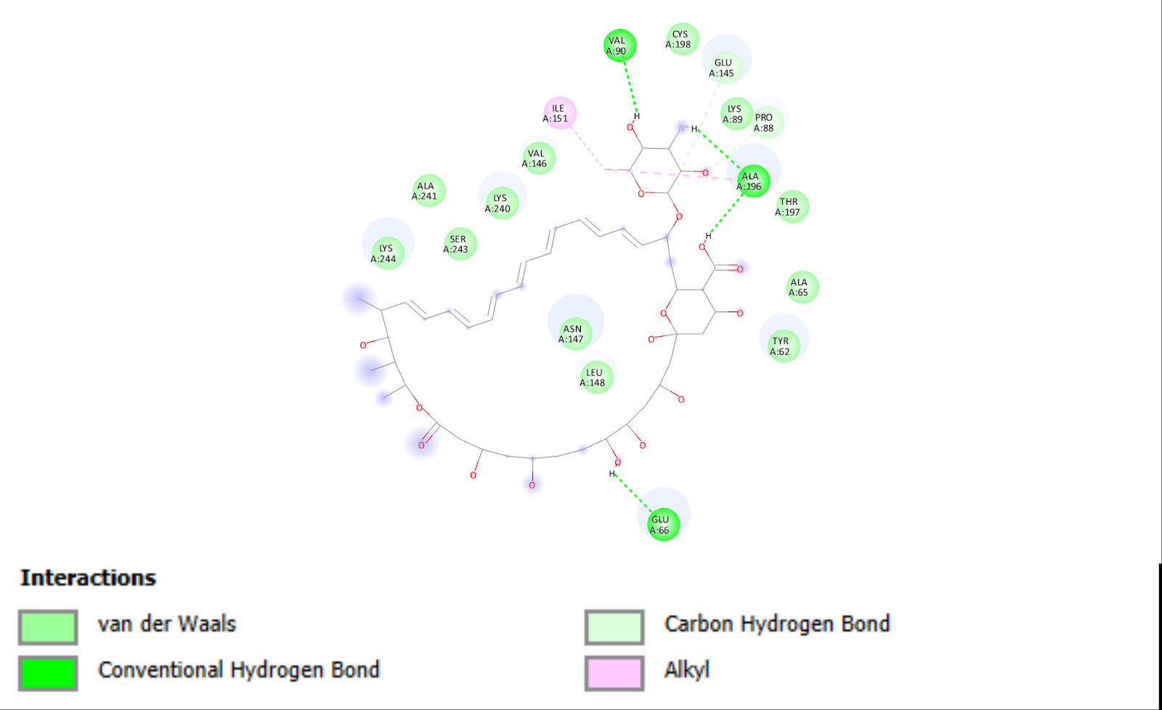

**Figure S2.** Illustration of the interaction of 60S ribosomal protein l7 putative and ligand CHEMBL267345.

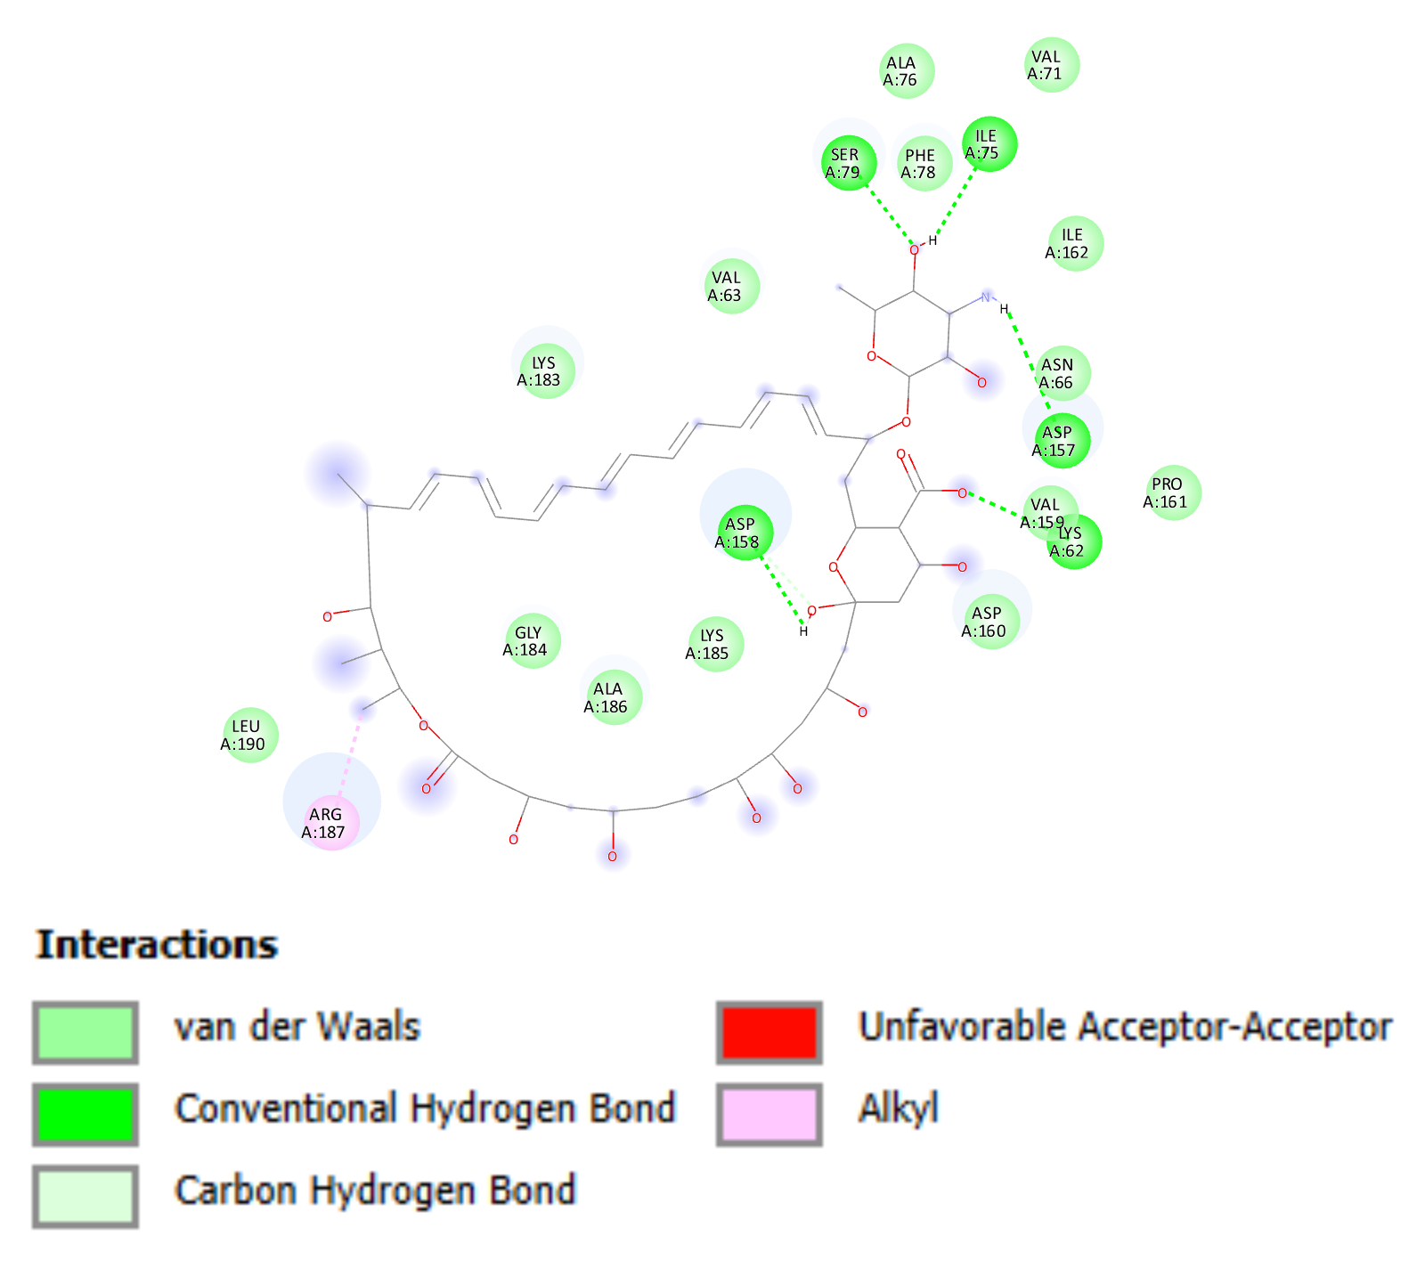

**Figure S3.** Illustration of the interaction of 60S ribosomal protein L8 and ligand CHEMBL267345.

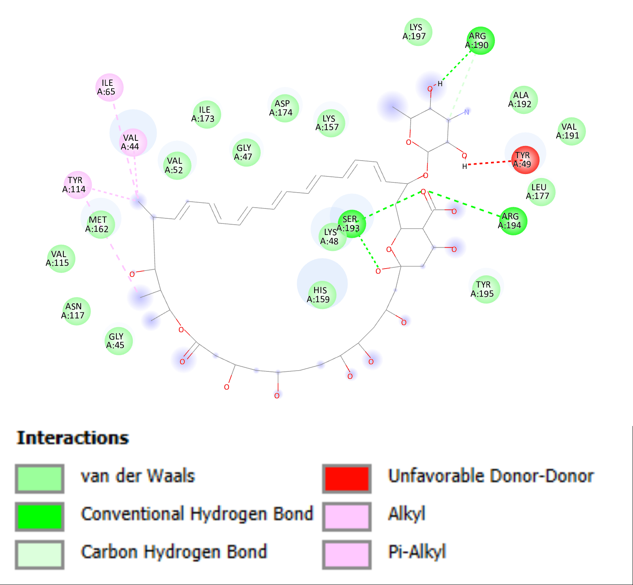

**Figure S4.** Illustration of the interaction of cka1 protein and ligand CHEMBL267345.

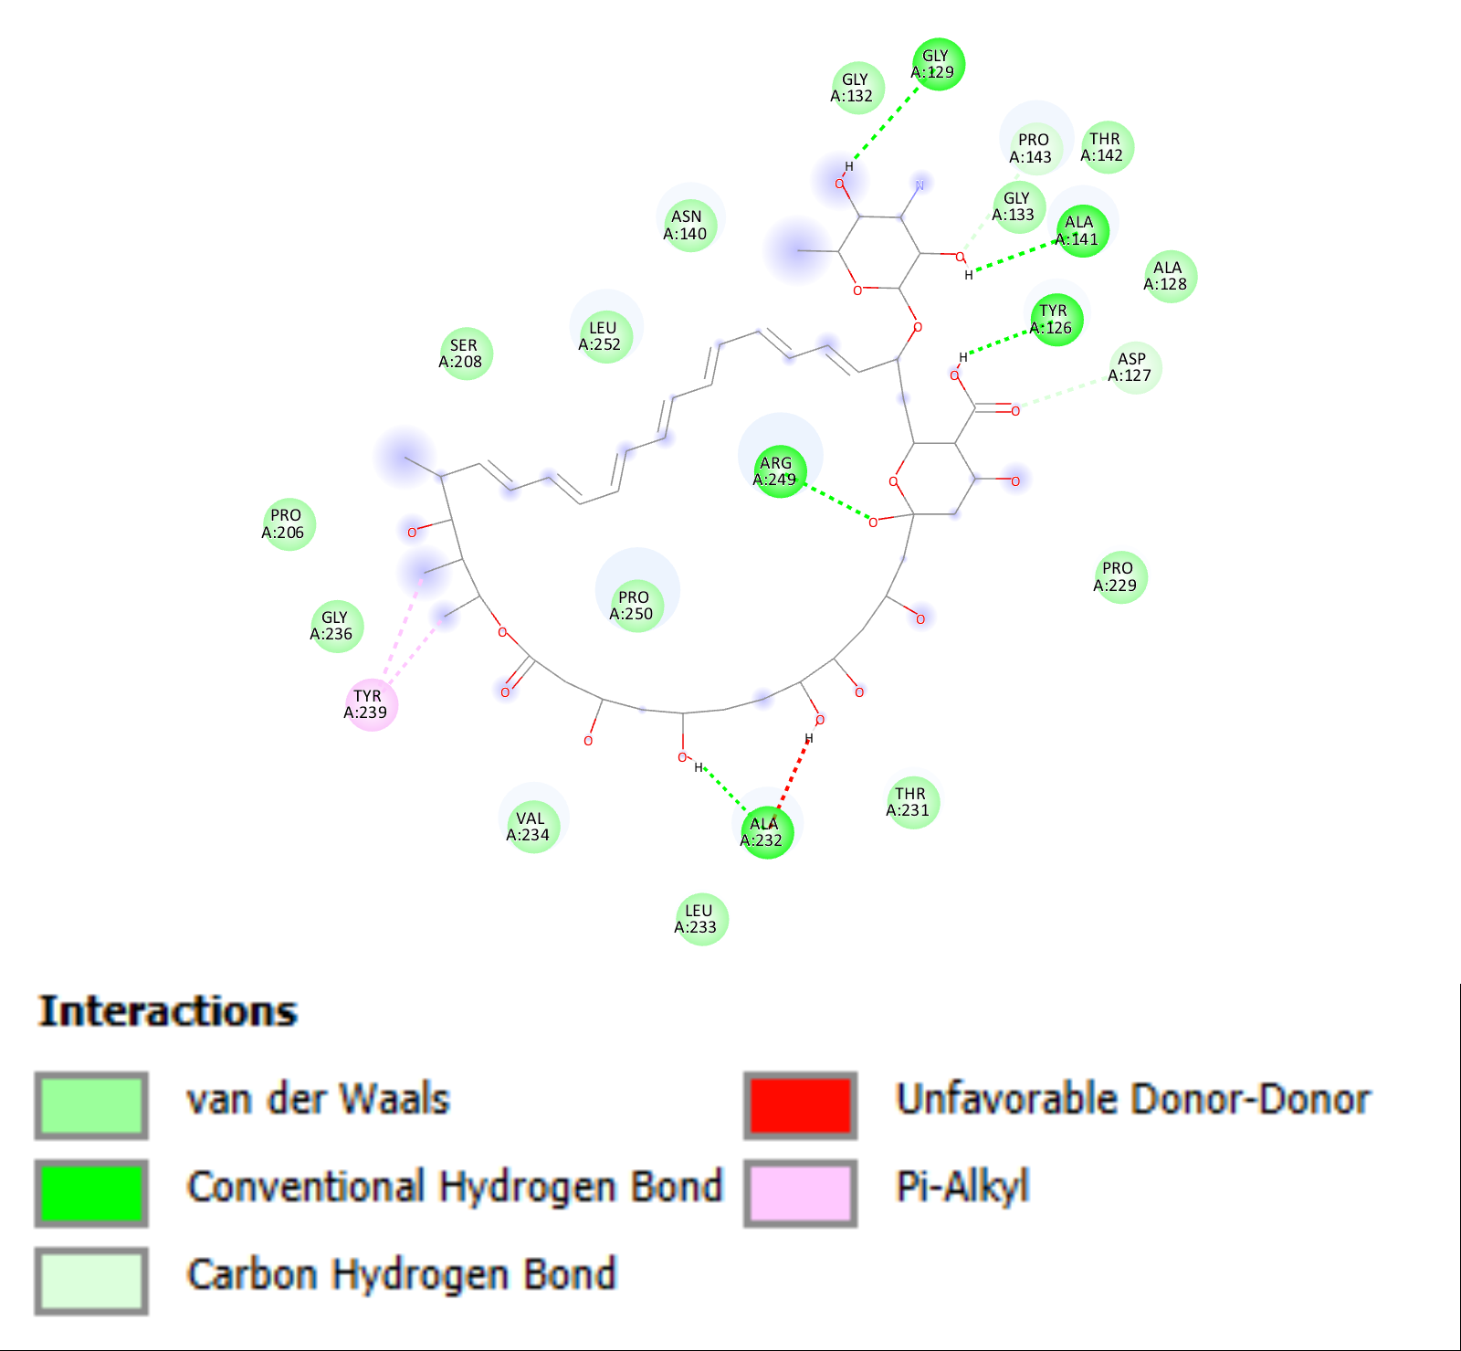

**Figure S5.** Illustration of the interaction of ckb1 protein and ligand CHEMBL267345.

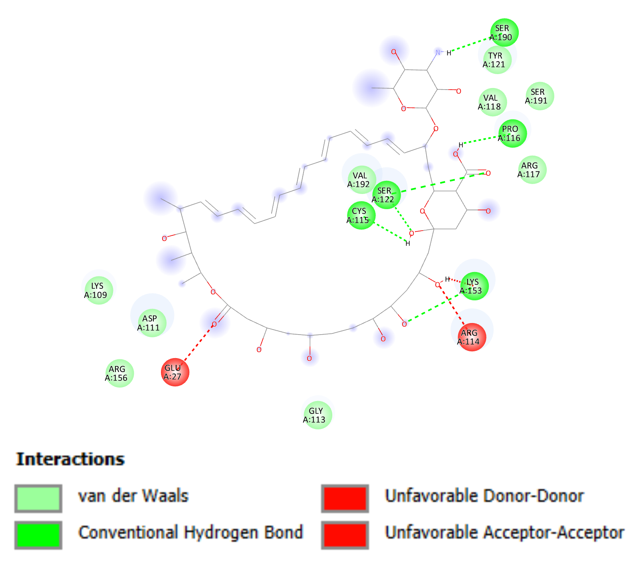

**Figure S6.** Illustration of the interaction of ckb2 protein and ligand CHEMBL267345.

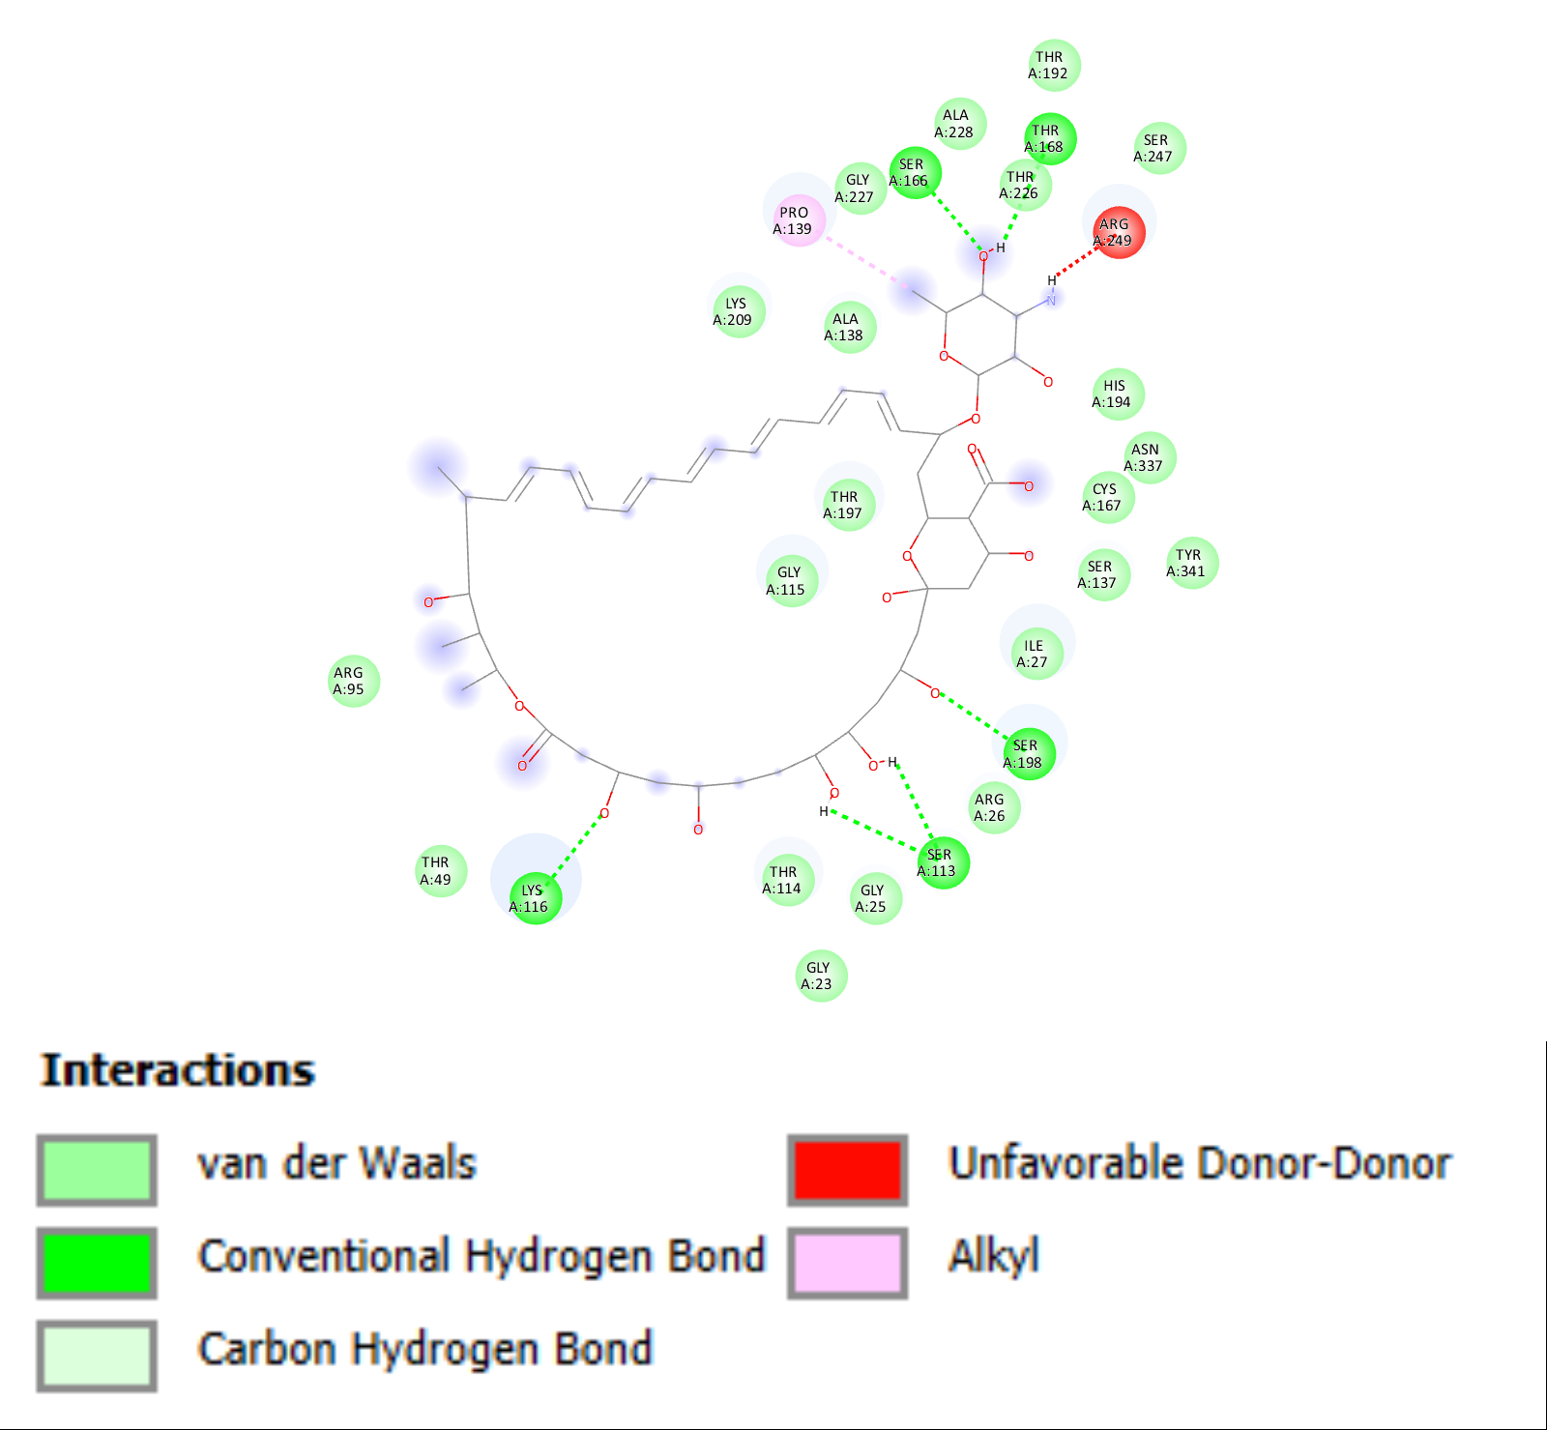

**Figure S7.** Illustration of the interaction of glyceraldehyde 3 phosphate dehydrogenase protein and ligand CHEMBL267345.

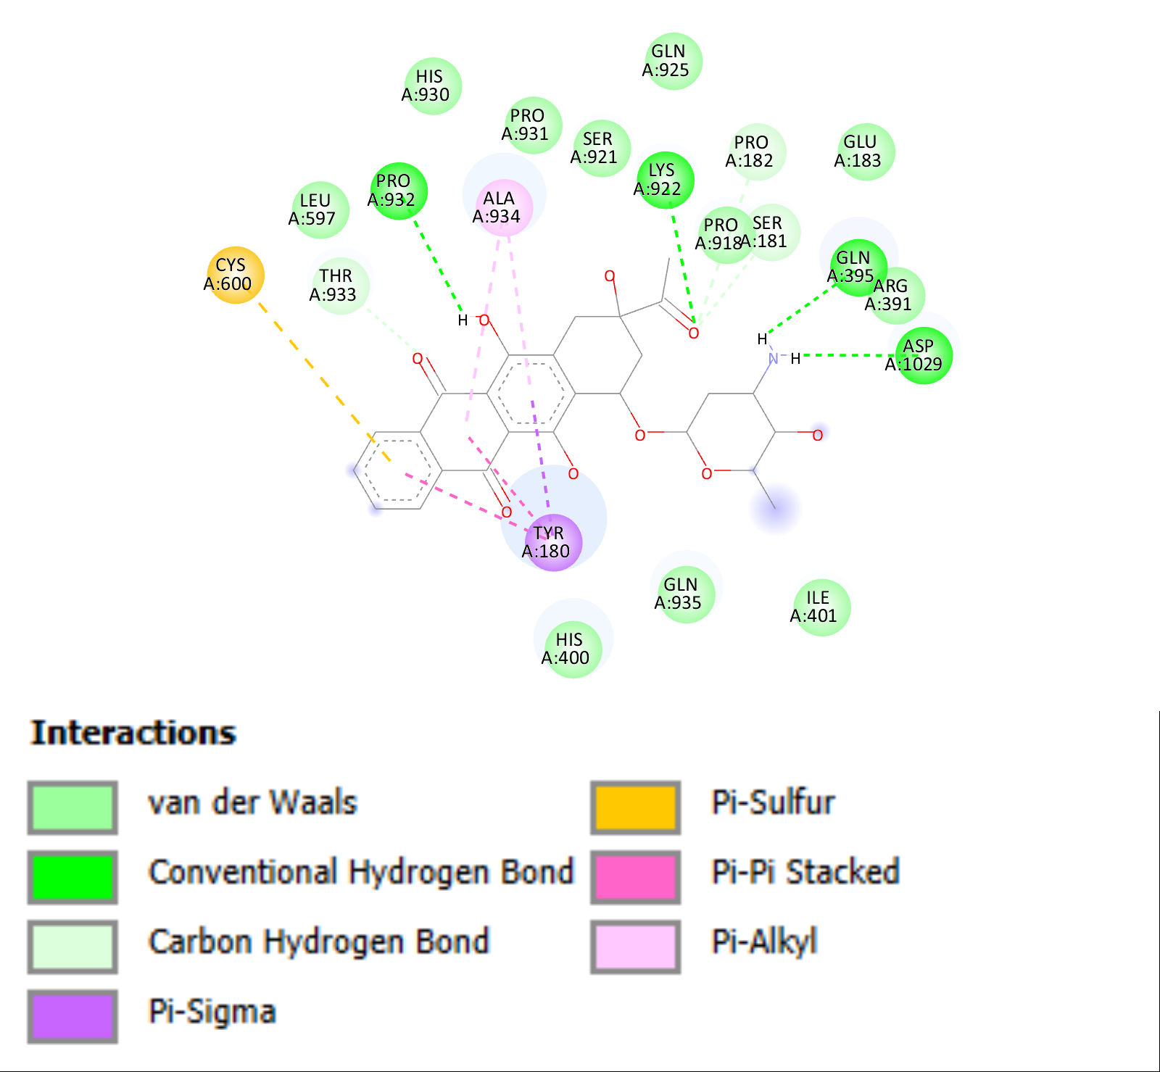

**Figure S8.** Illustration of the interaction of glycine cleavage protein and ligand CHEMBL1117.

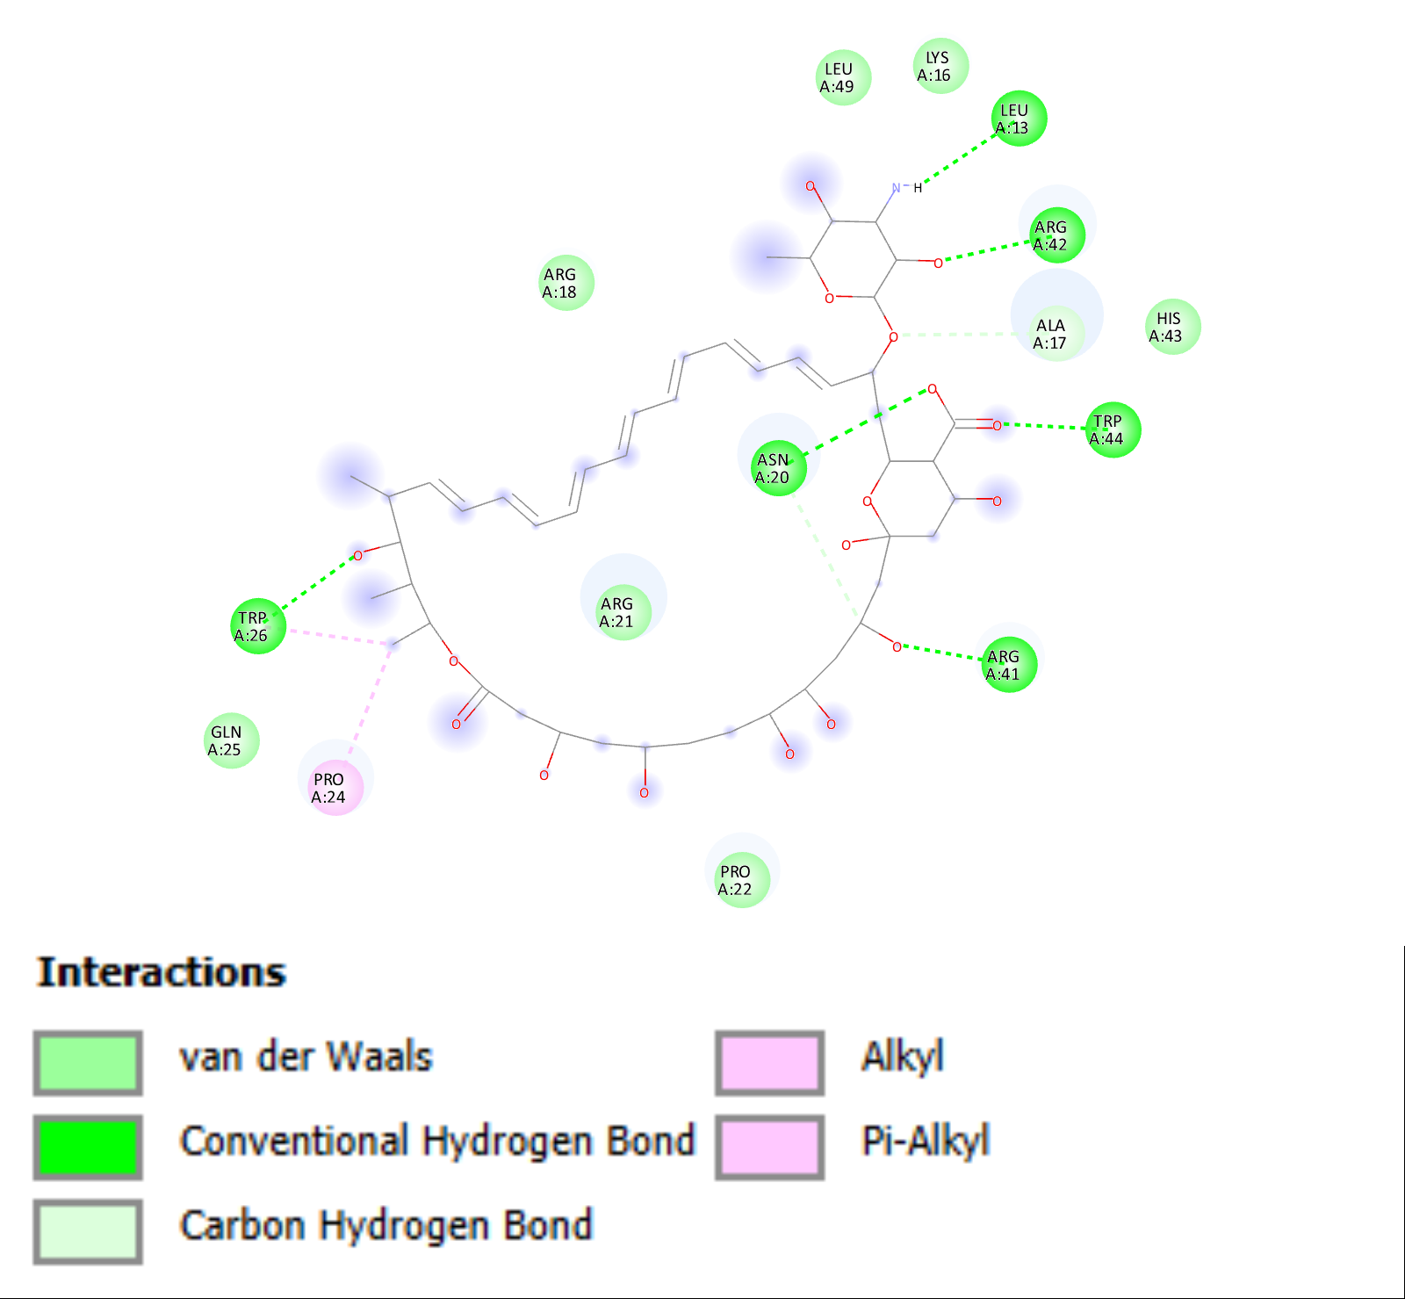

**Figure S9.** Illustration of the interaction of Large ribosomal protein eL39 protein and ligand CHEMBL267345.

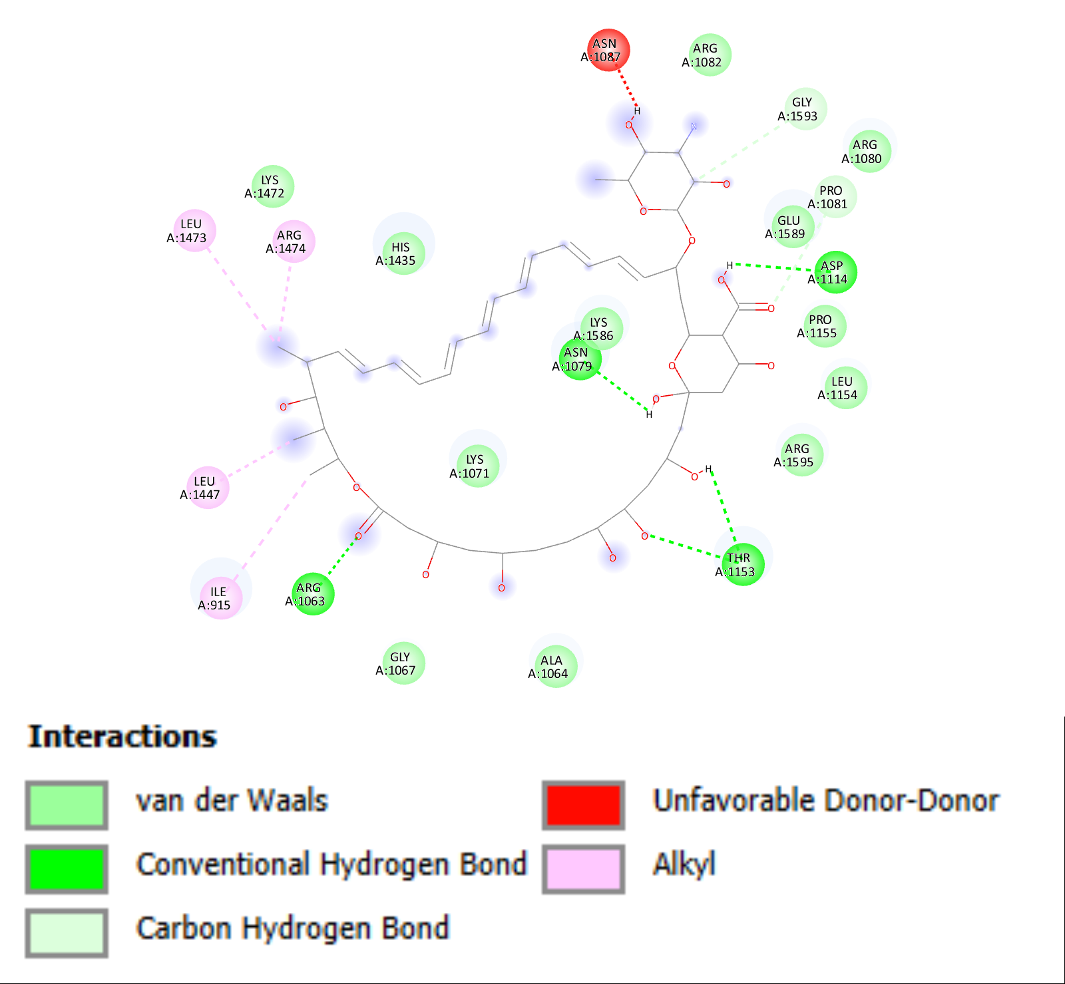

**Figure S10.** Illustration of the interaction of pentafunctional AROM polypeptide protein and ligand CHEMBL267345.

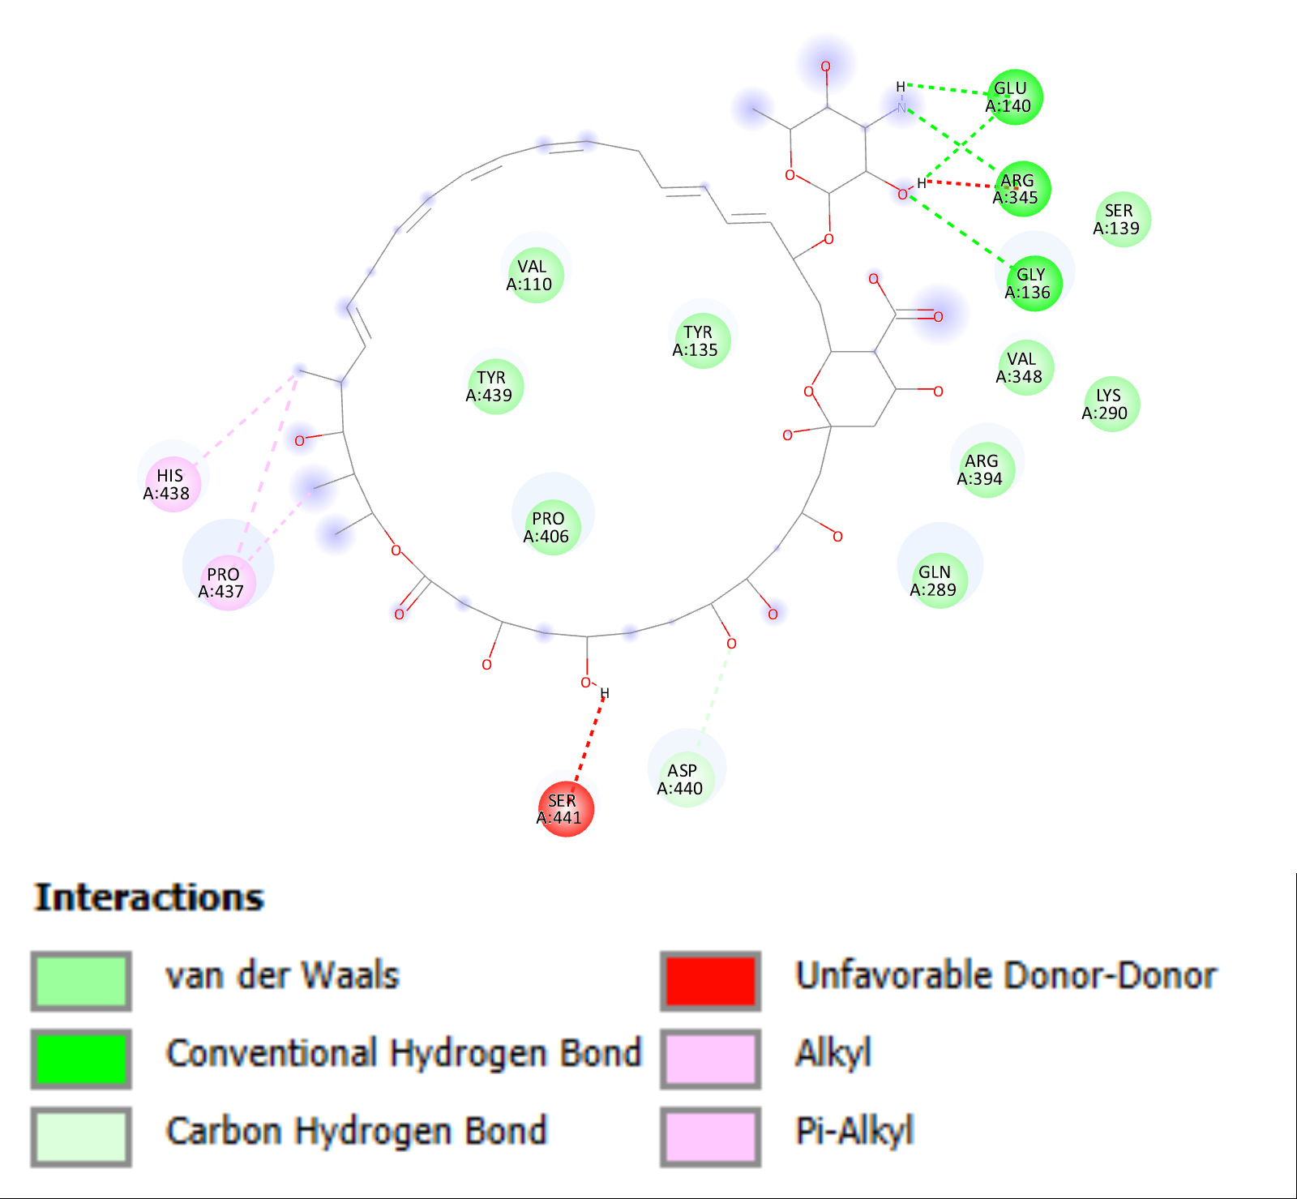

**Figure S11.** Illustration of the interaction of pyruvate carboxylase and ligand CHEMBL267345.

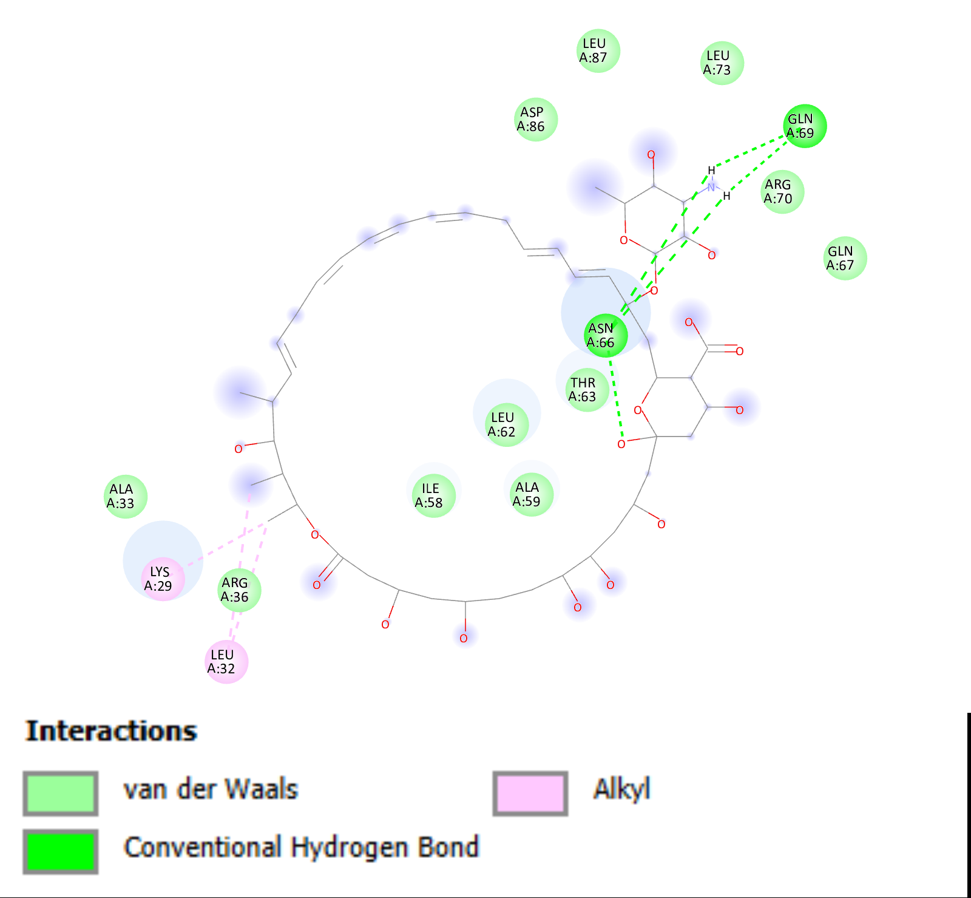

**Figure S12.** Illustration of the interaction of ribosomal protein L35 and ligand CHEMBL267345.

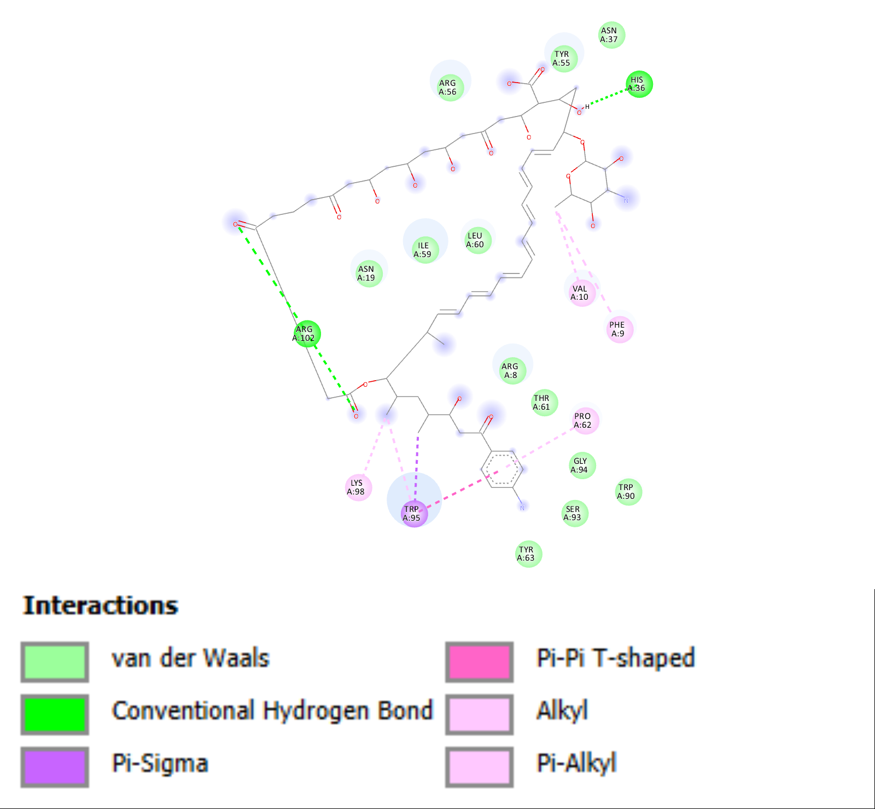

**Figure S13.** Illustration of the interaction of ribosomal protein putative and ligand CHEMBL1200647.

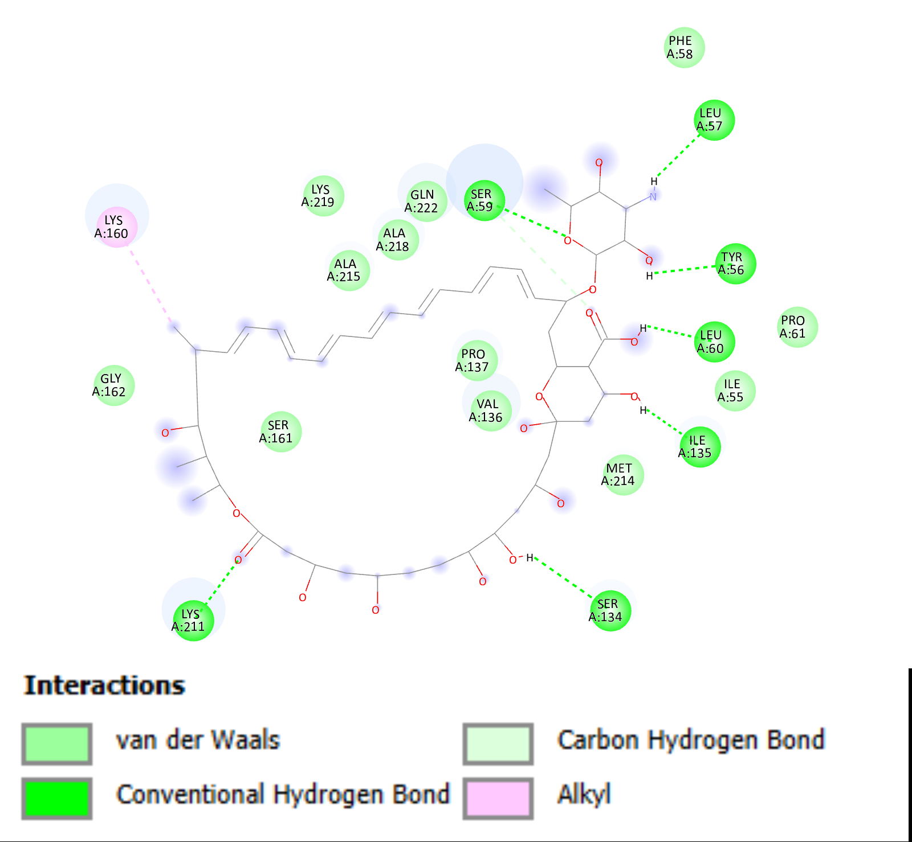

**Figure S14.** Illustration of the interaction of ribosomal protein S2 putative and ligand CHEMBL267345.

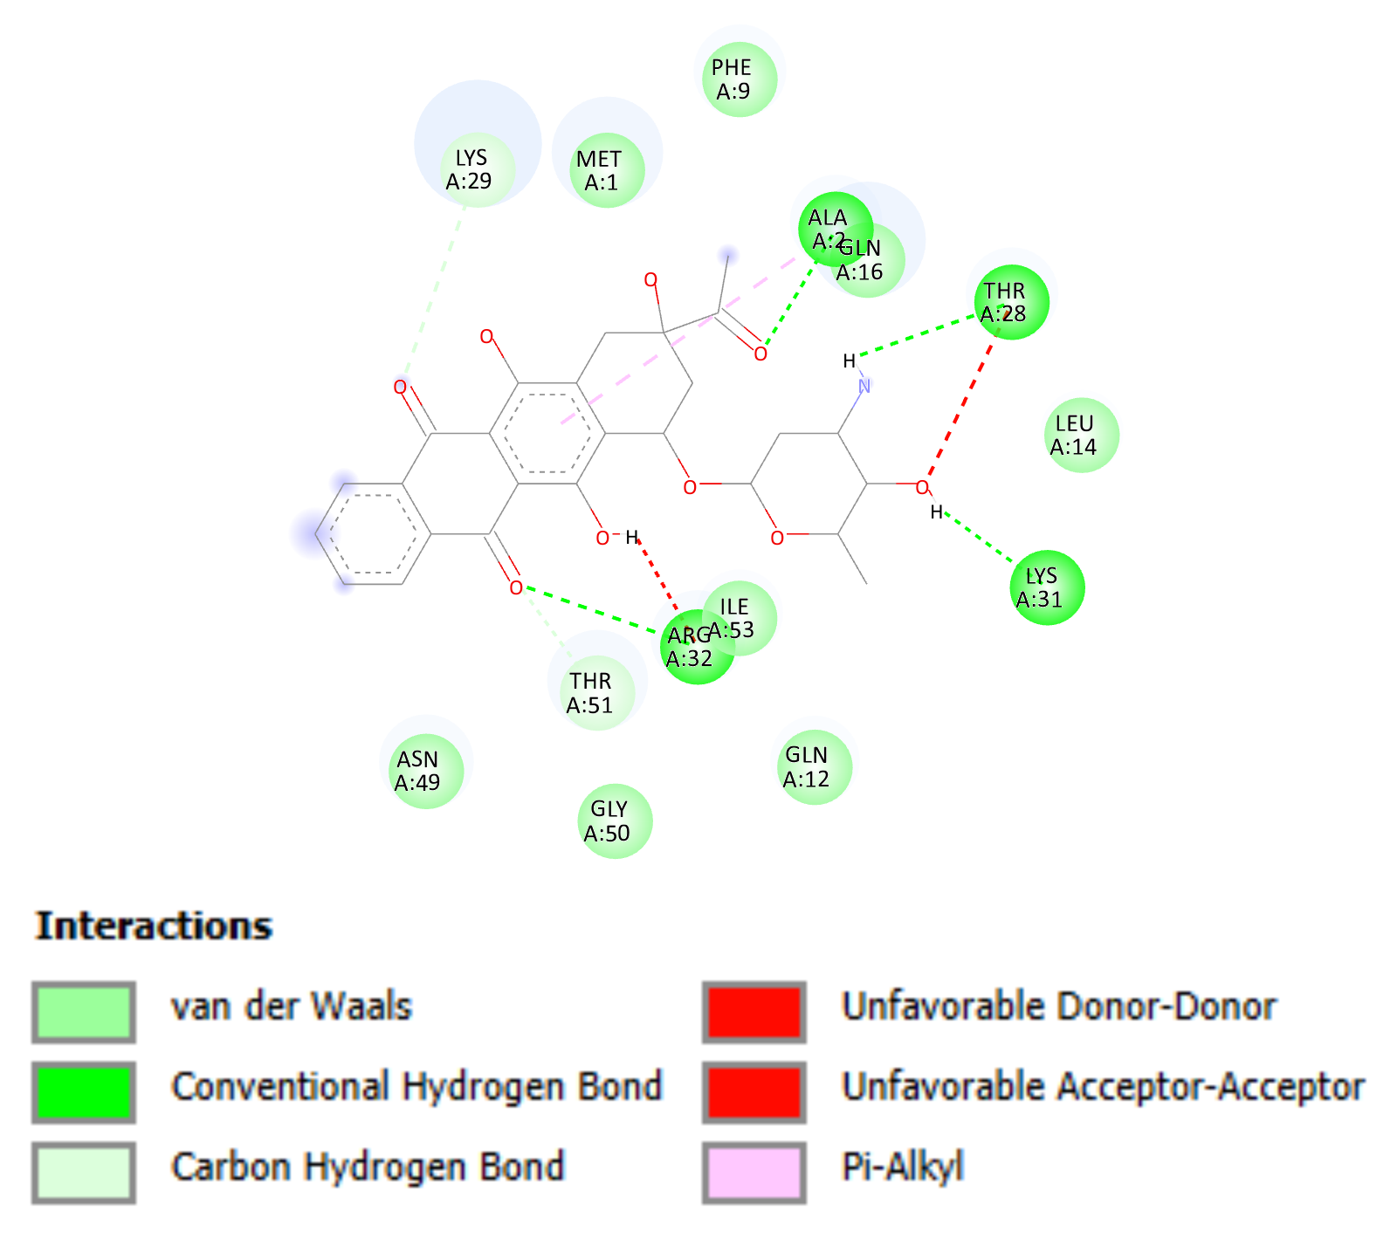

**Figure S15.** Illustration of the interaction of ribosomal protein S11 putative and ligand CHEMBL1117.

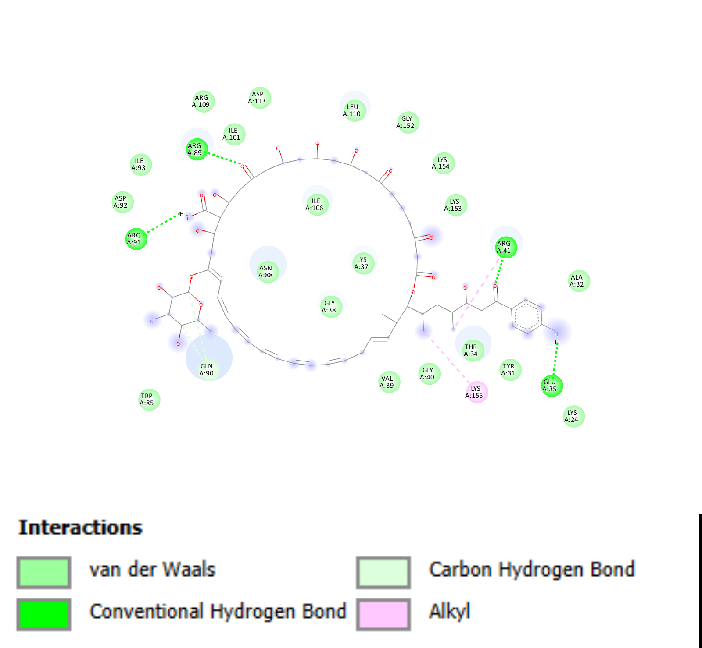

**Figure S16.** Illustration of the interaction of ribosomal protein S18 putative and ligand CHEMBL1200647.

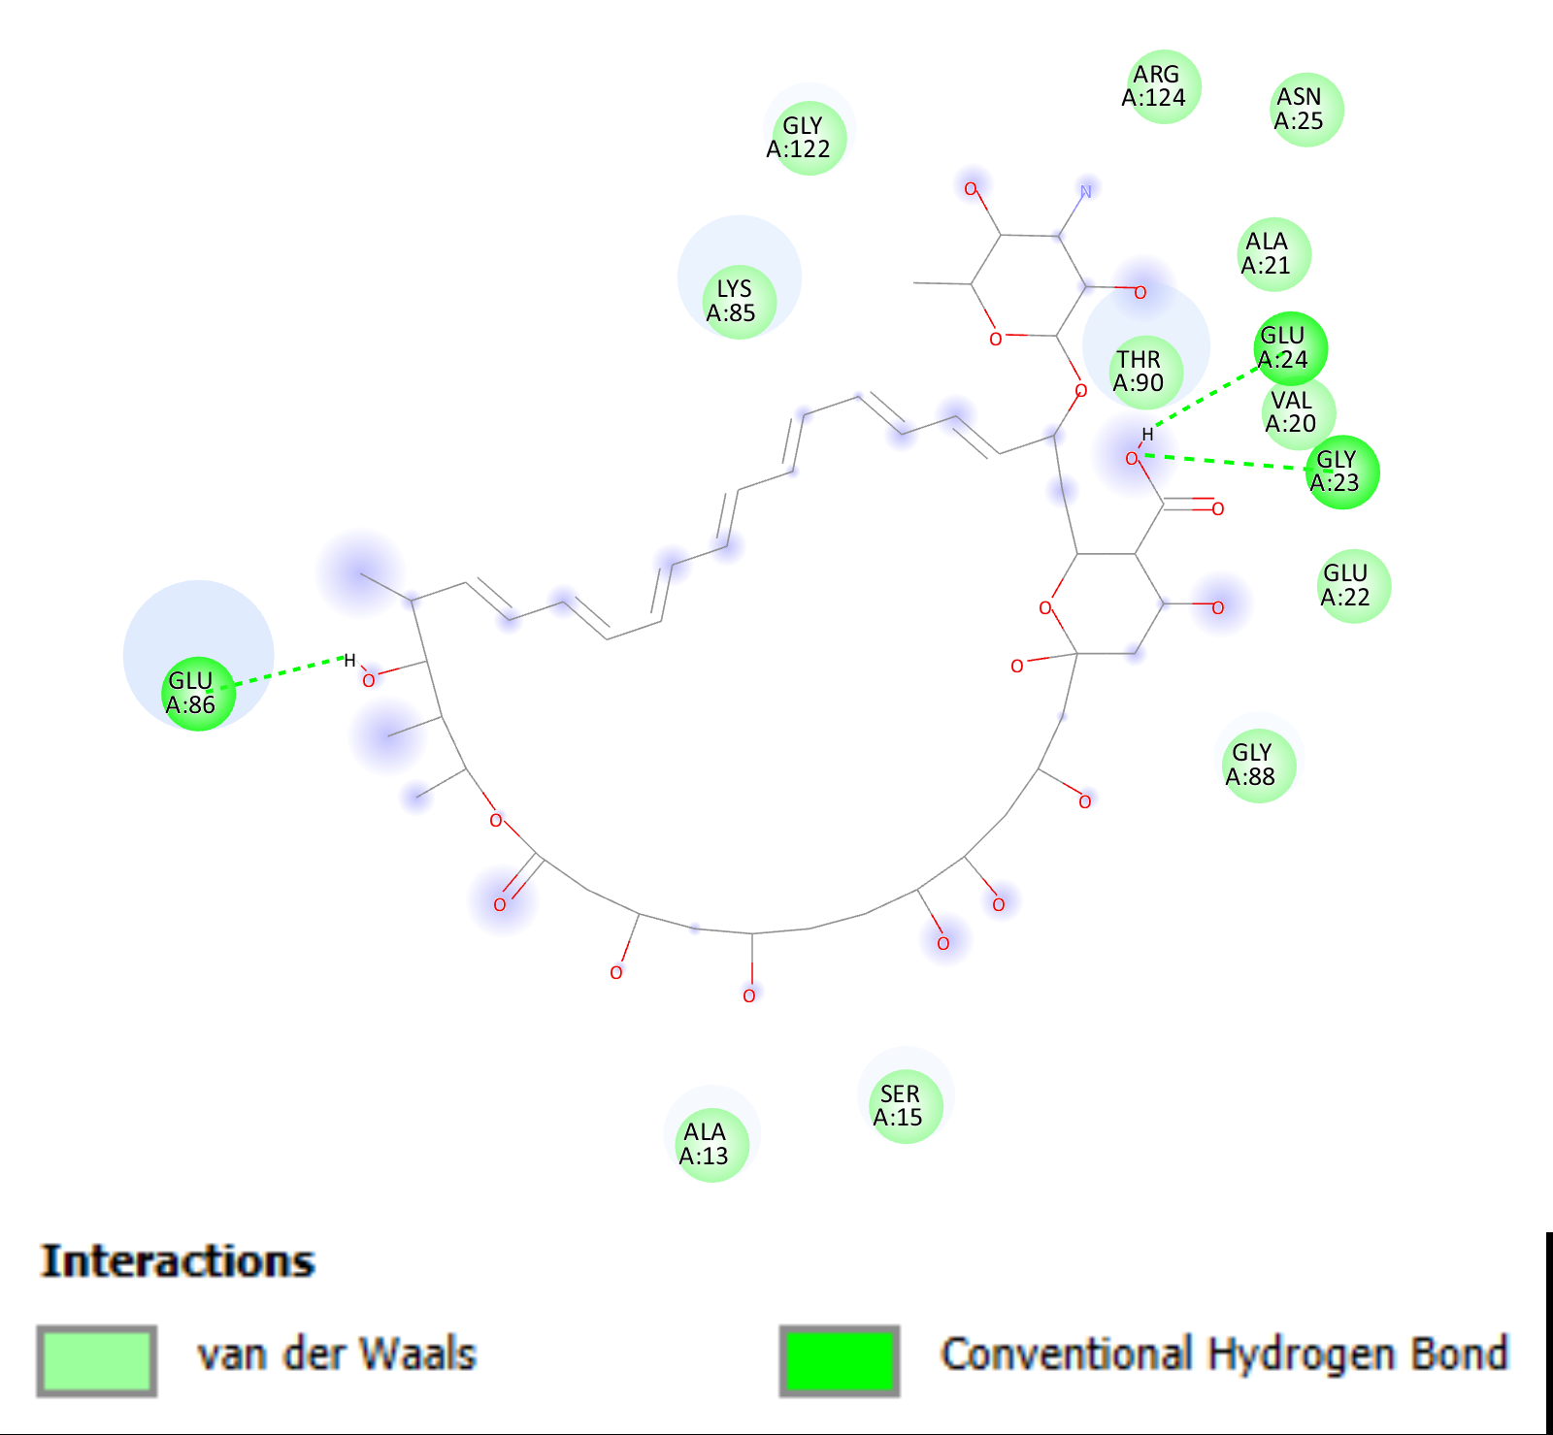

**Figure S17.** Illustration of the interaction of structural constituent of ribosome putative Q5KFT0 and ligand CHEMBL267345.

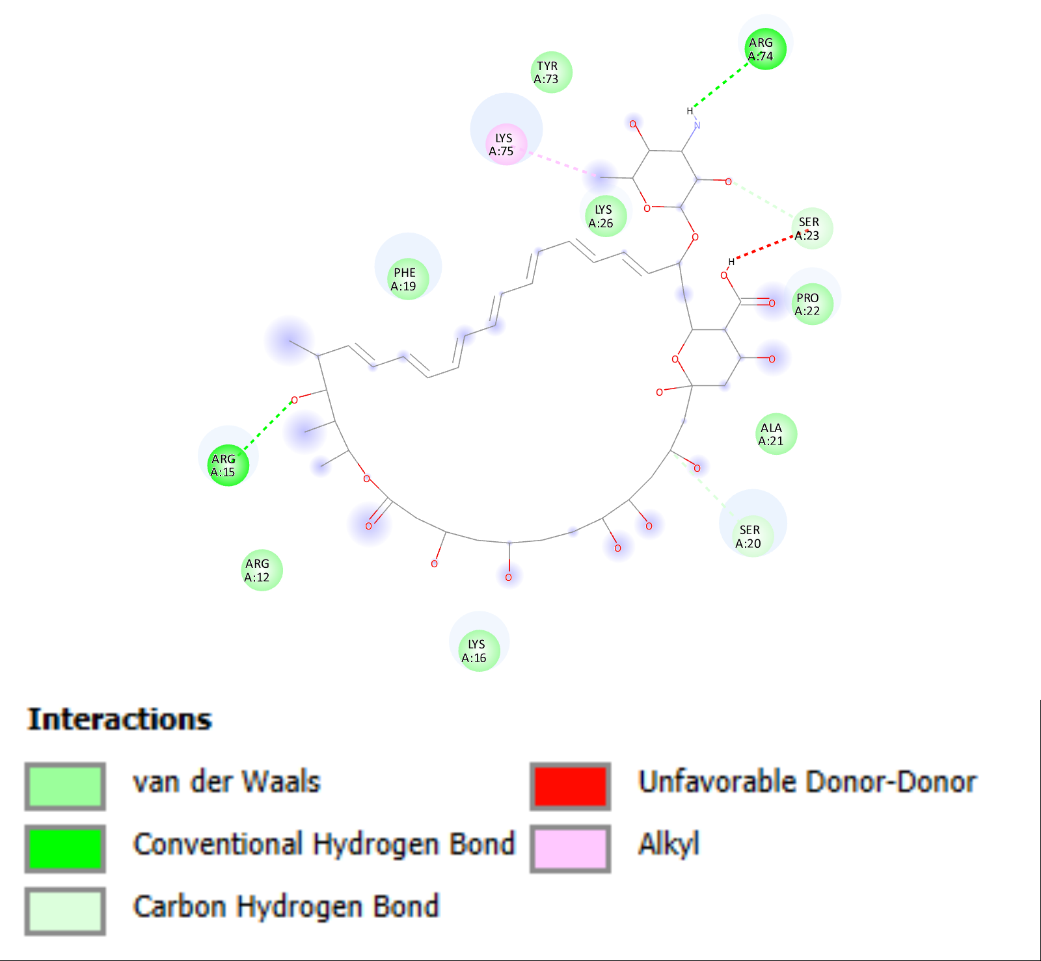

**Figure S18.** Illustration of the interaction of structural constituent of ribosome putative Q5KLJ6 and ligand CHEMBL267345.