1. **Upregulated and downregulated hub genes identification**

The top 10 upregulated and downregulated genes under the cka mutant condition along with their respective connectivity scores are displayed in **Tables S1** and **S2** respectively. In addition, the insights into the triple mutant condition's top 10 upregulated as well as downregulated genes linked with their connectivity scores are illustrated in **Tables S3** and **S4,** respectively. Furthermore, the top 10 upregulated and downregulated genes associated with wild vs all mutants condition along with their connectivity scores are represented in **Tables S5** and **S6**.

**Table S1.** Represents the cka vs mutant top 10 upregulated genes and their respective scores identified by Cytohubba in Cytoscape.

|  |  |
| --- | --- |
| **Upregulated Hub Genes** | **Scores** |
| Q5KKN1_CRYNJ | 13 |
| Q5KA63_CRYNJ | 11 |
| Q5KFT2_CRYNJ | 10 |
| Q5K997_CRYNJ | 10 |
| ARO1_CRYNJ | 10 |
| Q5KD10_CRYNJ | 9 |
| Q5KL19_CRYNJ | 9 |
| Q5KJU6_CRYNJ | 9 |
| Q5KG11_CRYNJ | 9 |
| Q5KC42_CRYNJ | 8 |

**Table S2.** Represents the cka vs mutant top 10 downregulated genes and their respective scores identified by Cytohubba in Cytoscape.

|  |  |
| --- | --- |
| **Downregulated Hub Genes** | **Scores** |
| Q5KP63_CRYNJ | 26 |
| Q5KEV1_CRYNJ | 24 |
| Q5KNH2_CRYNJ | 24 |
| Q5KFT0_CRYNJ | 24 |
| Q5KA46_CRYNJ | 24 |
| Q5KCS1_CRYNJ | 23 |
| Q5KCI8_CRYNJ | 21 |
| Q5KLJ6_CRYNJ | 21 |
| Q5KGV9_CRYNJ | 20 |
| Q5KN65_CRYNJ | 20 |

**Table S3.** Represents the triple vs mutant top 10 upregulated genes and their associated scores identified by Cytohubba in Cytoscape.

|  |  |
| --- | --- |
| **Upregulated Hub Genes** | **Scores** |
| Q5K997_CRYNJ | 16 |
| Q5K8G6_CRYNJ | 11 |
| Q5KKN1_CRYNJ | 10 |
| Q5KL19_CRYNJ | 9 |
| Q5K7S9_CRYNJ | 9 |
| Q5KD10_CRYNJ | 8 |
| ARO1_CRYNJ | 7 |
| Q5KC42_CRYNJ | 7 |
| Q5KJ61_CRYNJ | 7 |
| Q5KNI6_CRYNJ | 7 |

**Table S4.** Represents the triple vs mutant top 10 downregulated genes and their associated scores identified by Cytohubba in Cytoscape.

|  |  |
| --- | --- |
| **Downregulated Hub Genes** | **Scores** |
| Q5KJD4_CRYNJ | 44 |
| Q5KCS1_CRYNJ | 41 |
| Q5KK99_CRYNJ | 39 |
| Q5KJU2_CRYNJ | 39 |
| Q5KLJ6_CRYNJ | 38 |
| Q5KNH2_CRYNJ | 38 |
| Q5KMA0_CRYNJ | 37 |
| Q5K979_CRYNJ | 37 |
| Q5K947_CRYNJ | 37 |
| Q5KEV1_CRYNJ | 37 |

**Table S5.** Elucidates the wild vs all mutants' top 10 upregulated hub genes and their respective scores identified by Cytohubba in Cytoscape

|  |  |
| --- | --- |
| **Upregulated Hub Genes** | **Scores** |
| Q5KP63_CRYNJ | 29 |
| Q5KCS1_CRYNJ | 29 |
| Q5KNH2_CRYNJ | 27 |
| Q5KA46_CRYNJ | 27 |
| Q5KEV1_CRYNJ | 27 |
| Q5KFT0_CRYNJ | 26 |
| Q5KAB9_CRYNJ | 24 |
| Q5KN73_CRYNJ | 24 |
| Q5KLJ6_CRYNJ | 24 |
| Q5KHQ2_CRYNJ | 23 |

**Table S6.** Elucidates the wild vs all mutants' top 10 downregulated hub genes and their respective scores identified by Cytohubba in Cytoscape

|  |  |
| --- | --- |
| **Downregulated Hub Genes** | **Scores** |
| Q5K997_CRYNJ | 16 |
| Q5KKN1_CRYNJ | 13 |
| Q5KIM6_CRYNJ | 13 |
| Q5KA63_CRYNJ | 11 |
| ARO1_CRYNJ | 10 |
| Q5KL19_CRYNJ | 10 |
| Q5KD10_CRYNJ | 9 |
| Q5KFT2_CRYNJ | 9 |
| Q5KCT5_CRYNJ | 8 |
| Q5KJ92_CRYNJ | 8 |

**Identification of differentially expressed genes**

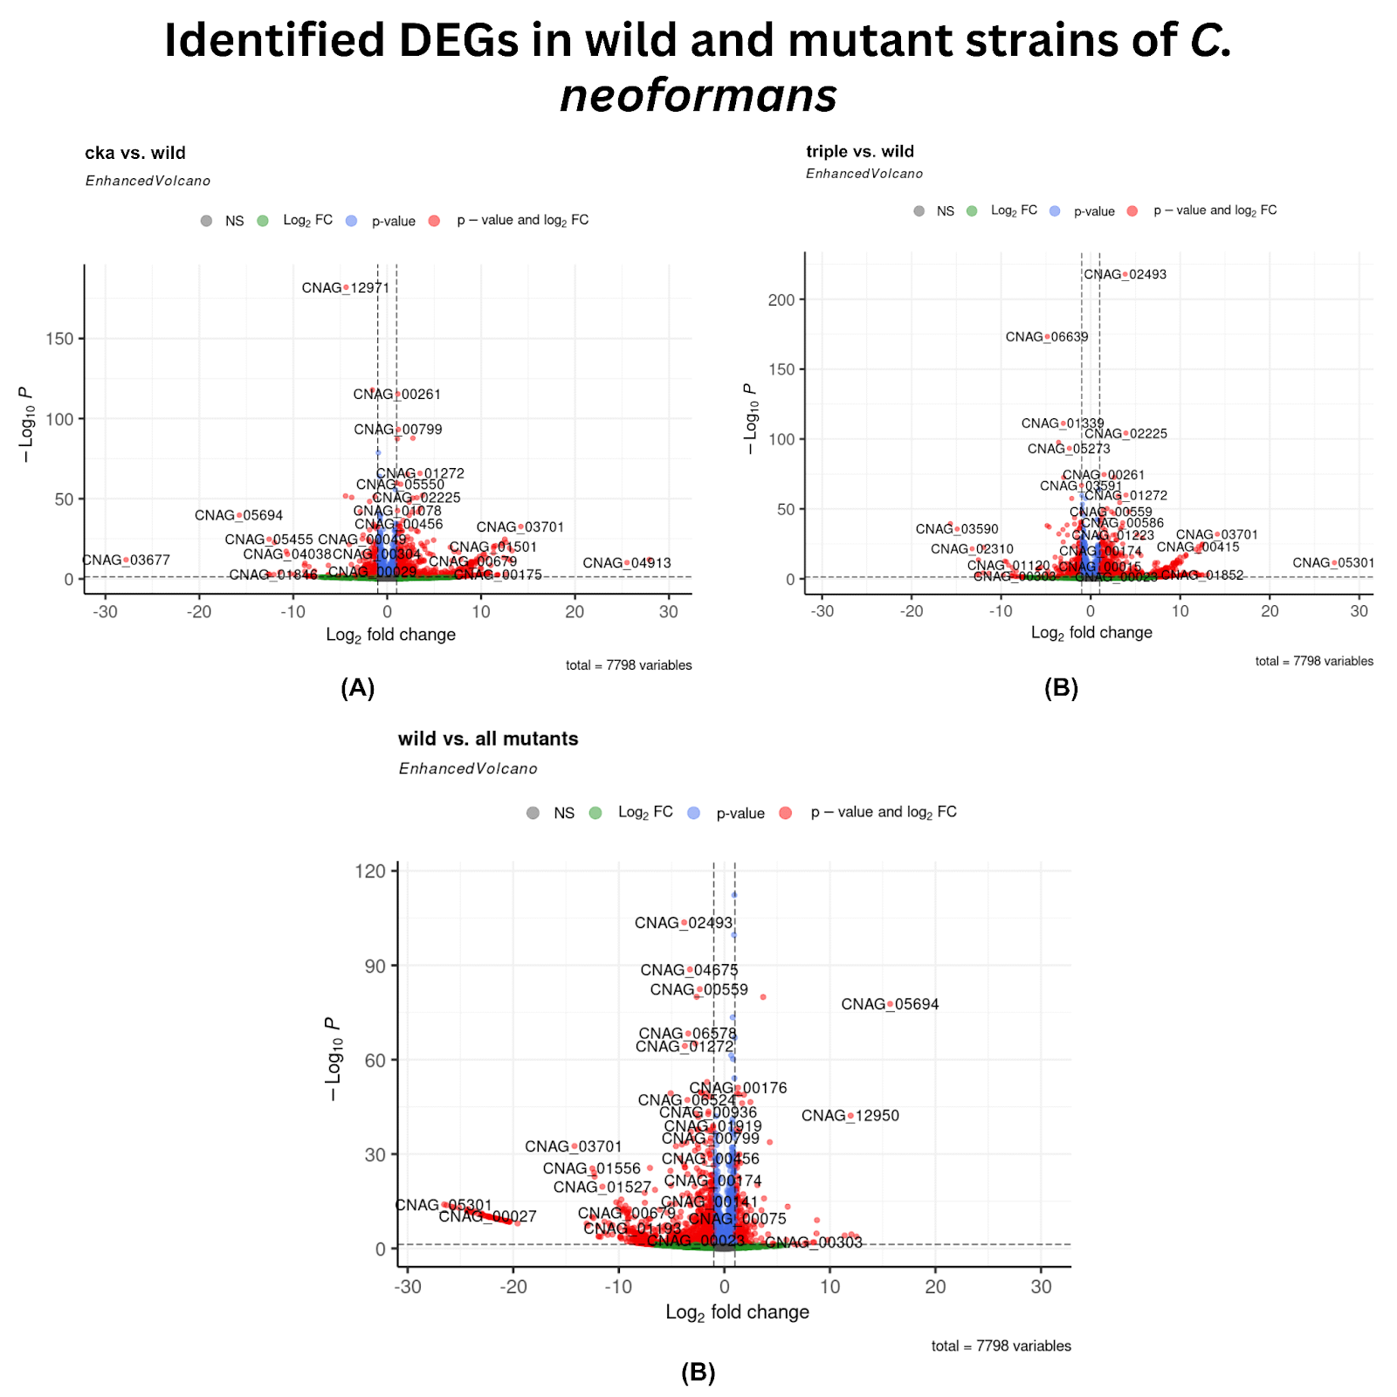

**Figure S1:** Volcano plot illustration of differentially expressed genes in three conditions **(A)** portraying DEGs in cka1Δ vs wild-type strain **(B) triple** vs wild-type strain, and **(C)** wild-type strain vs all mutants (cka1Δ, ckb1Δ, and ckb2Δ). Red colored dots represent upregulated and downregulated genes. Biologically significant genes are shown on the x-axis with respect to (w.r.t) Log2FC ± 1, and statistically significant genes are shown on the y-axis w.r.t Log10 P-value < 0.05. Hochberg-Bonferroni was employed for multiple corrections to obtain statistically significant genes.

**Figures for gene ontology (GO) pathways of upregulated genes**

**cka1Δ vs wild condition**

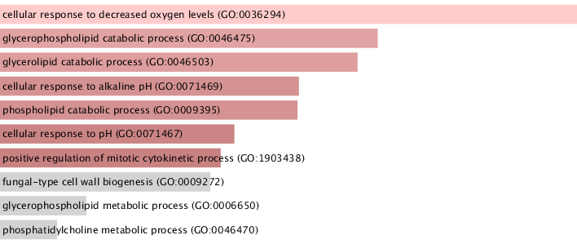

**Figure S2**. GO biological processes of upregulated genes. The Bargraph demonstrates the top 10 significant BP in upregulated genes. The light pinkish color represents more number of genes involved in BP, while the dark pink and grey color depicts less involvement of genes in BP.

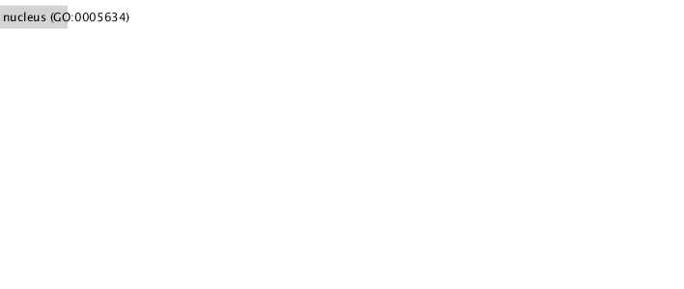**Figure S3.** GO cellular components of upregulated genes. The Bargraph demonstrates the top significant CC in upregulated genes.

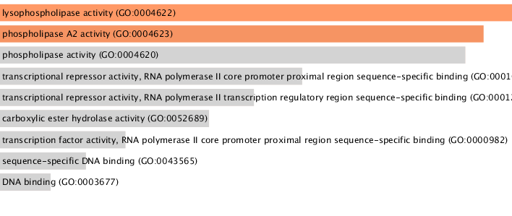**Figure S4.** GO molecular functions of upregulated genes. The Bargraph demonstrates the top 9 significant MF in upregulated genes. The orange color represents more number of genes involved in MF while the light grey color depicts less involvement of genes in MF.

**cka1Δ, ckb1Δ, and ckb2Δ (triple) vs wild condition**

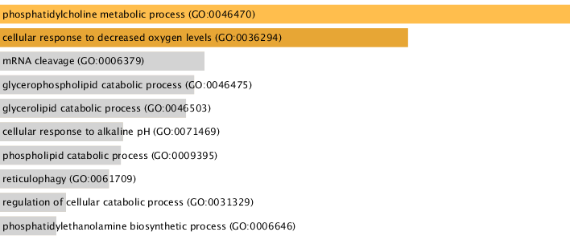

**Figure S5.** GO biological processes of upregulated genes. Barchart plot of top 10 significant BP in upregulated genes. The light yellow and yellow-brown color represents more number of genes involved in BP, while the light grey color represents fewer genes involved in BP.

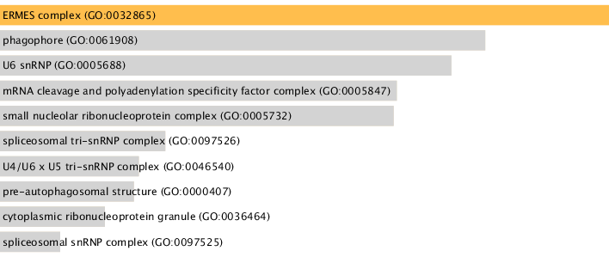

**Figure S6.** Upregulated genes in GO cellular components. Barchart plot of top 10 significant CC in upregulated genes. The yellow color represents more genes involved in CC, while the lighter color represents fewer genes involved in CC.

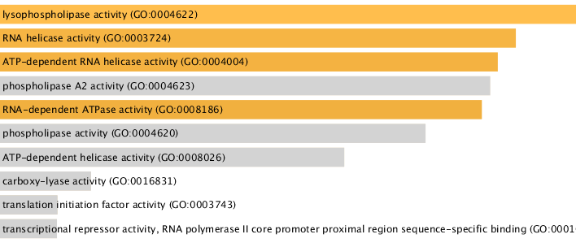

**Figure S7.** Upregulated genes in GO molecular functions. Barchart plot of top 10 significant MF in upregulated genes. The yellow color represents more genes involved in MF, while the grey color represents fewer genes involved in MF.

**Wild vs. cka1, ckb1, and ckb2 Mutants**

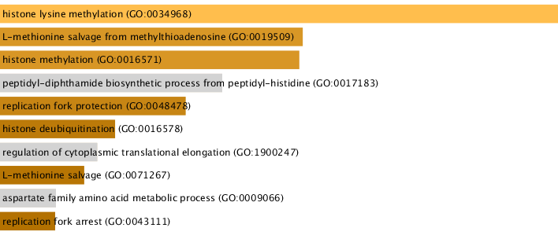

**Figure S8.** GO biological processes of upregulated genes. Barchart plot of top 10 significant BP in upregulated genes. The yellow and yellow-brown colors represent more genes involved in BP, while the grey and brownish color depicts fewer genes involved in BP.

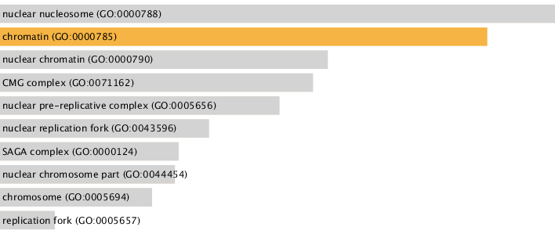

**Figure S9.** GO cellular components of upregulated genes. Barchart plot of top 10 significant CC in upregulated genes.

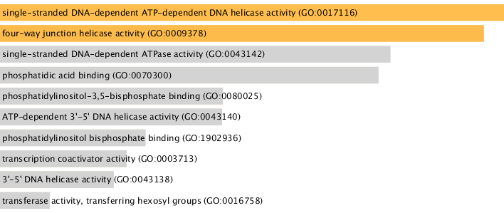**Figure S10.** GO molecular function of upregulated genes. Barchart plot of top 10 significant MF in upregulated genes. The yellow color represents more genes involved in MF, while the grey color represents fewer genes involved in MF.

**Figures for gene ontology (GO) pathways of downregulated genes**

**cka1Δ vs wild condition**

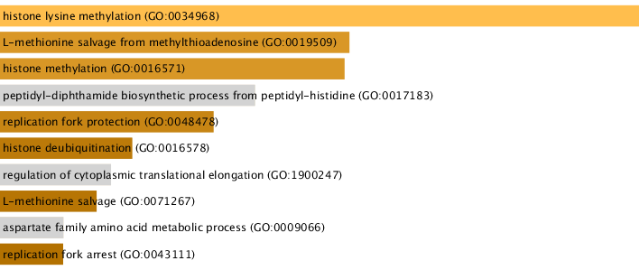**Figure S11**. GO biological processes of downregulated genes. The Bargraph demonstrates the top 10 significant BP in downregulated genes. The yellow color represents more number of genes involved in BP, while the yellow-brown and grey color depicts less involvement of genes in BP.

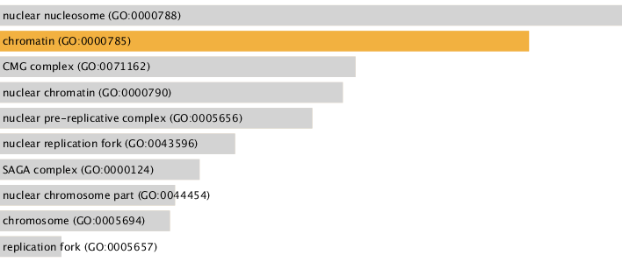**Figure S12.** Downregulated genes in GO cellular components. Barchart plot of top 10 significant CC in downregulated genes.

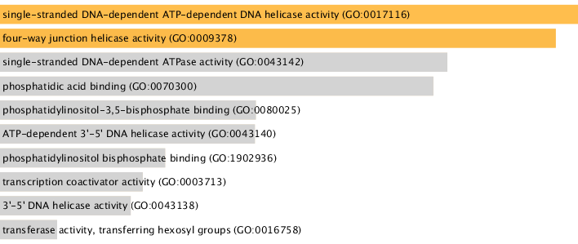

**Figure S13.**GO molecular functions of downregulated genes. The Bargraph demonstrates the top 10 significant MF in downregulated genes. The orange color represents more number of genes involved in MF while the grey color depicts less involvement of genes in MF.

**Triple vs wild condition**

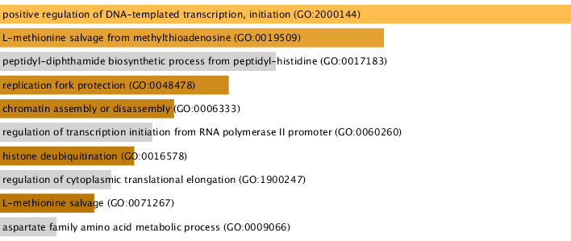

**Figure S14.** GO biological processes of downregulated genes. Barchart plot of top 10 significant BP in downregulated genes. The light yellow color represents more number of genes involved in BP, while the brown and grey color represents fewer genes involved in BP.

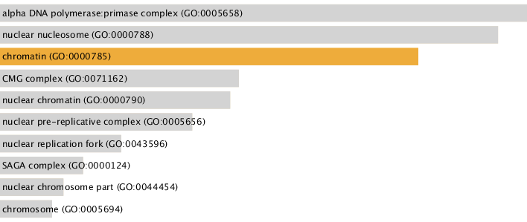

**Figure S15.** Downregulated genes in GO cellular components. Barchart plot of top 10 significant CC in downregulated genes.

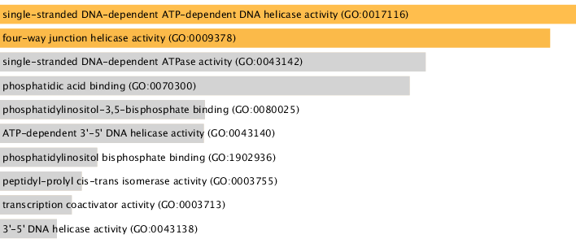

**Figure S16.** Downregulated genes in GO molecular functions. Barchart plot of top 10 significant MF in downregulated genes. The yellow color represents more genes involved in MF, while the grey color represents fewer genes involved in MF.

**3. Wild vs. cka1, ckb1, and ckb2 Mutants**

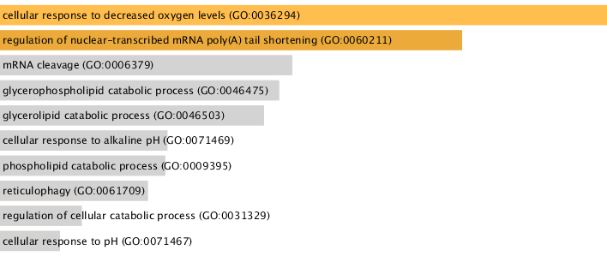

**Figure S17.** GO biological processes of downregulated genes. Barchart plot of top 10 significant BP in downregulated genes. The yellow color represents more genes involved in BP, while the grey color depicts fewer genes involved in BP.

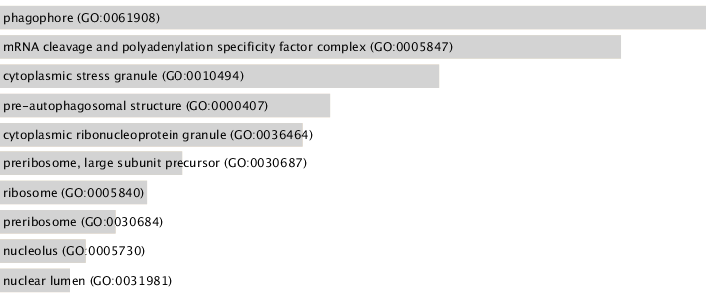

**Figure S18.** GO cellular components of downregulated genes. Barchart plot of top 10 significant CC in downregulated genes.

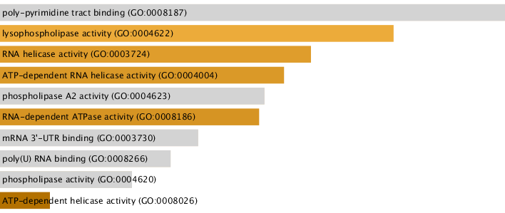

**Figure S19.** GO molecular function of downregulated genes. Barchart plot of top 10 significant MF in downregulated genes.

**Pathway enrichment analysis**

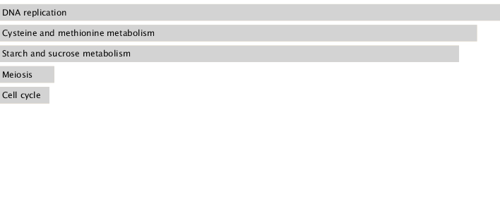

**Figure S20.** KEGG pathway analysis of the downregulated genes in cka1 vs. wild condition using YeastEnrichr4 showing the bar chart plot of the top enriched KEGG pathways. The grey color represents the involvement of genes in the specific pathways.

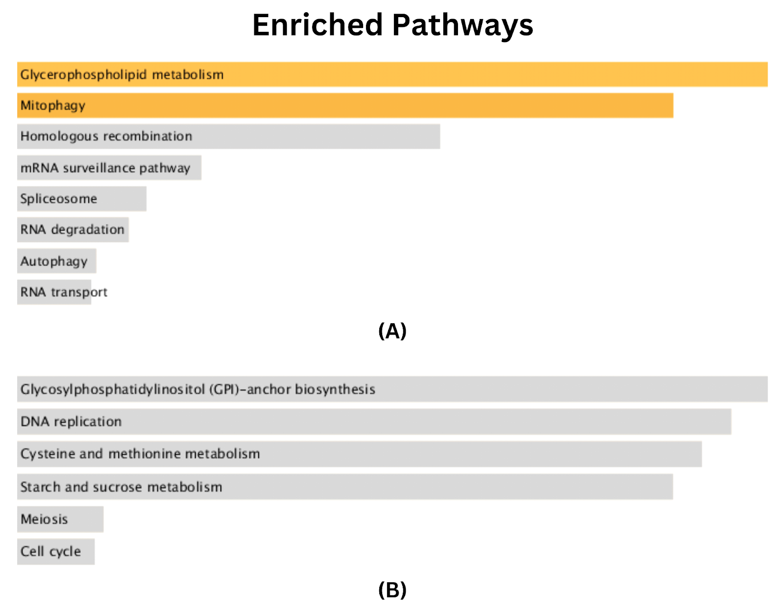

**Figure S21:** **(A)** Pathway enrichment analysis of triple vs mutant upregulated genes showing the bar chart plot of the top 10 enriched KEGG pathways. **(B)** pathway analysis of the upregulated genes of wild-type strain vs all mutant conditions showing the bar chart plot of the top 10 enriched KEGG pathways.

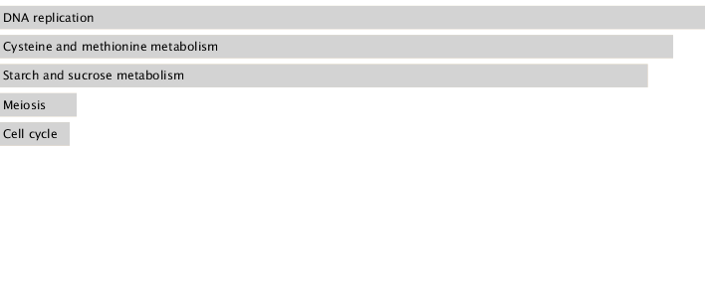

**Figure S22.** KEGG pathway analysis of the downregulated genes in triple vs wild condition using YeastEnrichr4 showing the bar chart plot of the top enriched KEGG pathways. The grey color represents the involvement of genes in the specific pathways.

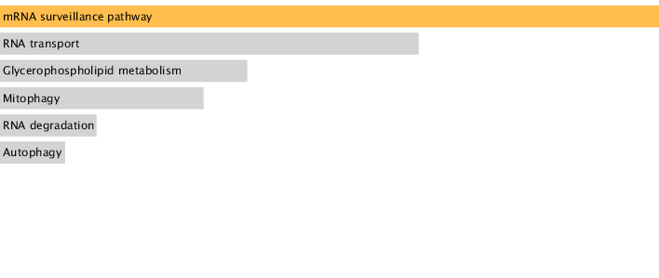

**Figure S23.** KEGG pathway analysis of the downregulated genes in wild vs. cka1, ckb1, and ckb2 Mutant conditions using YeastEnrichr4 showing the bar chart plot of the top enriched KEGG pathways. The yellow and grey colors represent the genes involved in the specific pathways.

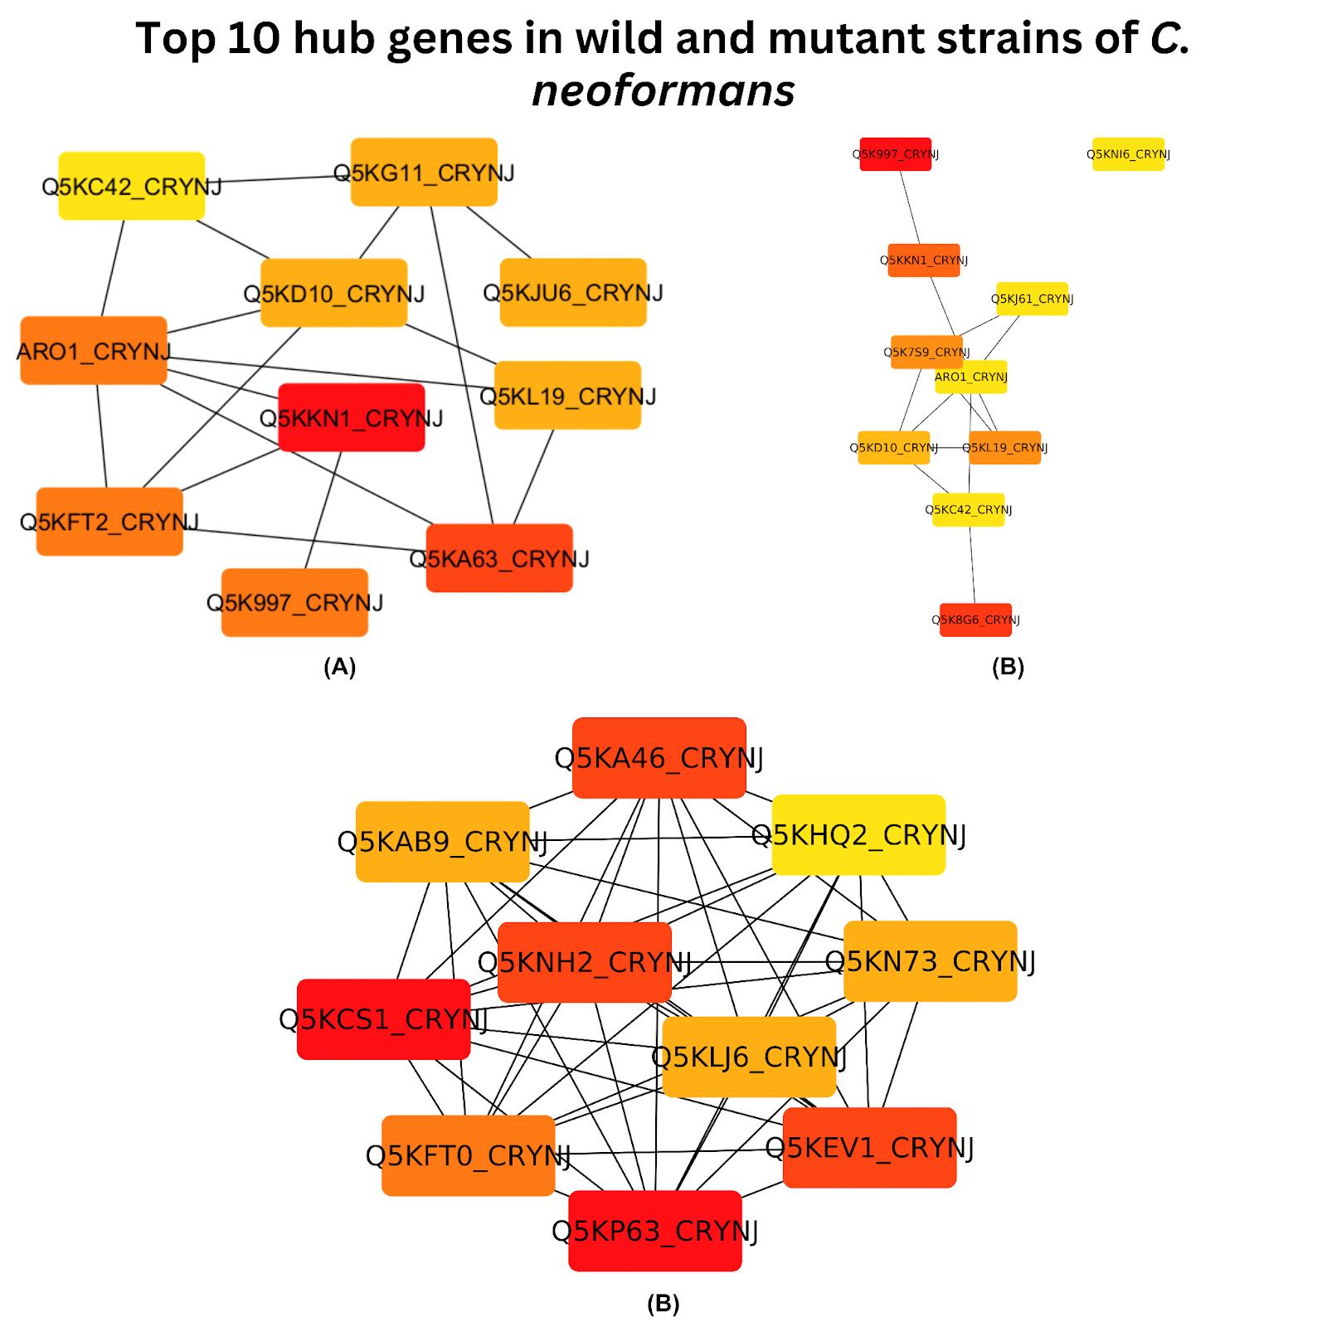

**Figure S24: (A)** Illustration of top 10 upregulated hub genes network associated with cka1 vs wild-type strain c conditions **(B)** Top 10 upregulated hub genes network of triple vs wild-type strain condition **(C)**. The hub genes network of the top 10 upregulated genes in the wild-type strain vs all mutant conditions.